

**MOBILE MULTIMEDIA AND GAMING**

**GROUP ASSIGNMENT**

**CT041-3-3**

**Members:** ANG CHEE SIAH (TP038259)

LIM ZHI DA (TP041644)

SEE RONG JIE (TP038306)

**Intake code:** UC3F1805CGD

**Module:** MOBILE MULTIMEDIA AND GAMING (CT041-3-3)

**Lecturer’s Name:** DR. CHEN TET KHUAN

MR. JACOB SOW TIAN YOU

**Submission Date:** 5th SEPTEMBER 2018

Table of Contents

Introduction 1

Literature Review 1

Game Reviews: ANG CHEE SIAH 2

Game Reviews: LIM ZHI DA 12

Game Reviews: SEE RONG JIE 21

Design & Method 30

Game Overview 30

Level Design 31

Game Story 34

Adapted Concepts 35

System Implementation & Analysis 37

Created Classes 37

Implemented Algorithms 41

User Manual/Guide 42

Test Cases 42

Conclusion 43

Workload Matrix 43

References 44

Appendix A: Game Manager Script 45

Appendix B: Board Manager Script 46

Appendix C: Player Script 47

Appendix D: Flash Trigger Script 49

Appendix E: Level Manager Script 49

Appendix F: Dialogue Manager Script 53

Appendix G: *itch.io* Website of **I’m The Skilled Driver** 55

# Introduction

This assessment focuses on delivering a game in the format of mobile application, also known as the mobile game. In this case, we were given the theme of Puzzle, where the mobile game must include puzzle-solving elements of any kind, and have certain degree of continuity. The requirements of the output are as follows:

* Game must be playable in mobile platform (either iOS or Android platforms)
* Game must include puzzle elements
* Game must be able to run for at least 3-5 levels, if there is any need to implement levels.

In this case, the output of this assessment is decided to be a storytelling game with inclusion of a semi-roguelike puzzle, where the platform is expected to be in Android platform, made via the Unity Editor.

# Literature Review

The review of the following games has been conducted among the members respectively:

|  |  |  |  |
| --- | --- | --- | --- |
| **Members** | **ANG CHEE SIAH** | **LIM ZHI DA** | **SEE RONG JIE** |
| **Game Reviewed 1** | *1BeatHeart* | *Inside* | *Mekorama* |
| **Game Reviewed 2** | *Dungeon Cards* | *Samsara* | *Monster Strike* |
| **Game Reviewed 3** | *Potion Maker* | *Snipperclips:*  *Cut It Out, Together* | *Causality* |
| **Game Reviewed 4** | *Dungeon & Girls:*  *Card RPG* | *Lara Croft Go* | *Divine Gate* |
| **Game Reviewed 5** | *Baldi's Basics in Education and Learning* | *The Witness* | *Where Shadows Slumber (Demo)* |

## Game Reviews: ANG CHEE SIAH

1. *1BeatHeart*

* **PUBLISHER**: △○□× (Miwashiba)   
  **OTHER GAMES PUBLISHED**: Alicemare, LiEat, 1BitHeart
* **GENRE**: Adventure-Platformer
* **DESCRIPTION**: A couple investigating strange murder cases that occurred in a resort hotel.

**HOW TO PLAY**:

Encounter a case, find evidences and testimonies, interrogate suspect & find contradictions within the suspect’s lies by presenting collected evidences (vgperson, 2017)as in ***FIGURE 1.01***.

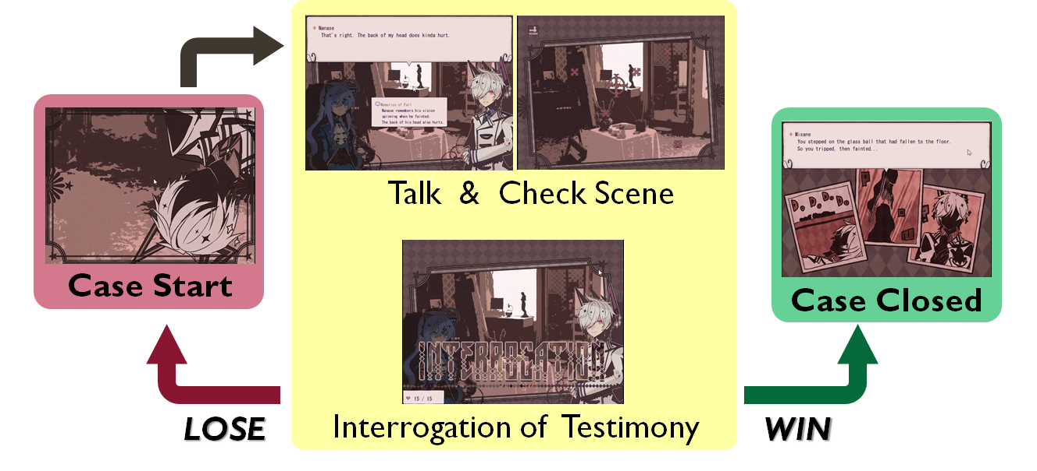

***FIGURE 1.01: General Overview of 1BeatHeart Gameplay***

In an example of the gameplay, the main character, Misane, is required to check the cause of her partner being unconscious, and begins the gameplay of a ‘chapter’.

There are a few steps that occur during the gameplay, with reference to ***FIGURE 1.02***:

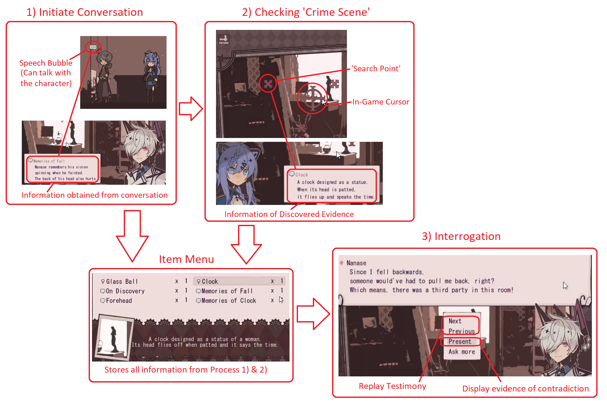

***FIGURE 1.02: 1BeatHeart Gameplay Example (1 Chapter)***

1. Initiate **conversation** with interactable characters (shown by floating speech bubble) to gather intel. (Information would be stored in Item Menu)
2. Check the ‘crime scene’ and collect **evidence** by searching through the area. (Evidence would be stored in Item Menu too)
3. Begin **interrogation** with the suspect and **find contradictions** in suspect’s testimony by presenting the collected information.

* The player is given 15 chances, referred as ‘15 HP’ for each chapter in the game, and each wrong option chosen in interrogation would result to 1 HP being deducted.
* The game is over when the HP is deducted to 0, and the current chapter would restart.
* While when the game is cleared when all contradictions in the suspect’s testimony has been resolved, the game would advance to the next chapter until all chapters are cleared.

**WIN CONDITION**

* Success in interrogating culprit/Uncover all culprit’s lies

**LOSE CONDITION**

* ‘Heart’/ ‘HP’/Chance drops to 0

**GAME MECHANICS**

* *CHARACTERS*
  + Evidence providers OR Interrogate targets/culprits (shiba, 2017)

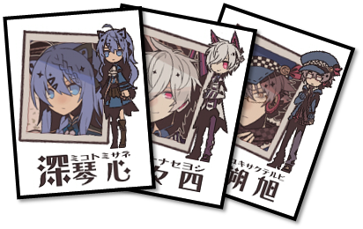

* *ITEMS*
  + Evidence & certain Testimonies/Alibis are kept in Item Menu as items to trigger-use in Interrogations

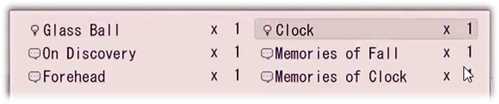

* *ENVIRONMENT*
  + 2D Platformer-based environment

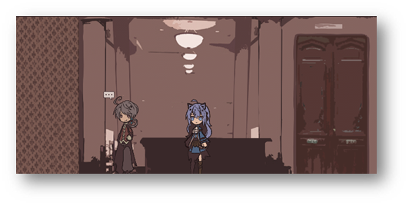

1. *Dungeon Cards*

* **PUBLISHER**: 717 Pixels (Pixels, 2018)  
  **OTHER GAMES PUBLISHED**: NONE
* **GENRE**: Roguelike-Puzzle
* **DESCRIPTION**: An adventurer exploring in a dungeon to earn money while destroying monsters and traps

**HOW TO PLAY**:

Move horizontally or vertically on a 3x3 dungeon card map and get as many money/gold as you can. Kill monsters and traps or get killed by them instead as seen in ***FIGURE 1.03***.

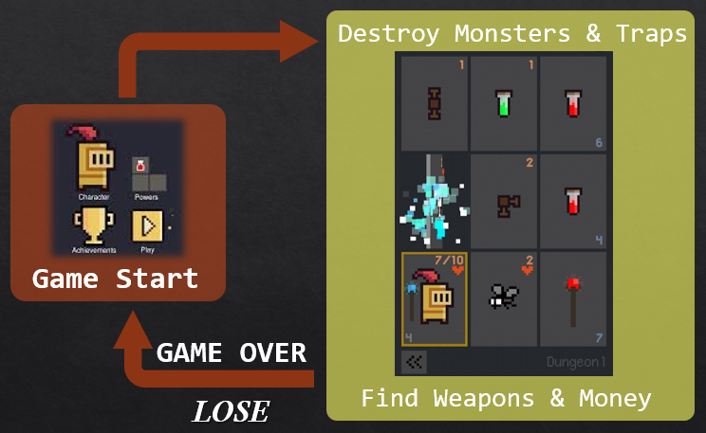

***FIGURE 1.03: General Overview of Dungeon Cards Gameplay***

In general, the player is equipped with Health Points (HP) where the moment the player touches the monsters or traps while moving, the **player’s HP would be reduced** by the **value** the monster or trap carries as shown in ***FIGURE 1.04***. If the player is **equipped with a weapon**, the **weapon’s HP** would be deducted instead of the player’s.

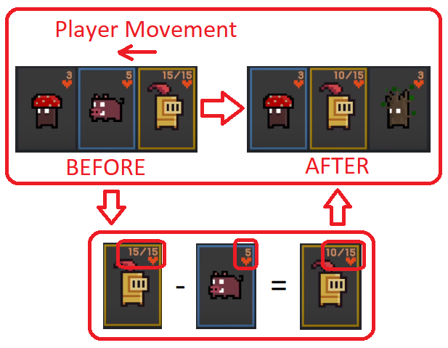

***FIGURE 1.04: Damage Calculation in Dungeon Cards***

During gameplay, the player could obtain **money** from destroying monsters or traps, where the accumulated money as shown in ***FIGURE 1.05*** could be used to **unlock new characters or powers** that brings benefits such as healing the player, damage immunity to certain traps, and so on.

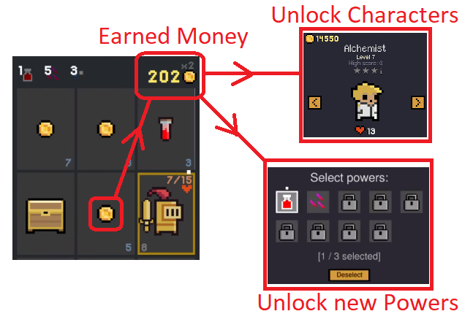

***FIGURE 1.05: Money Usage in Dungeon Cards***

The game ends when the player’s HP hits 0. The amount of money obtained would count as the ‘high score’ of the game. Therefore, this game is of a endless run.

**WIN CONDITION**

* None

**LOSE CONDITION**

* When player HP drops to 0

**GAME MECHANICS**

* *CHARACTERS*
  + Player Card (Player Card type changeable at Menu)

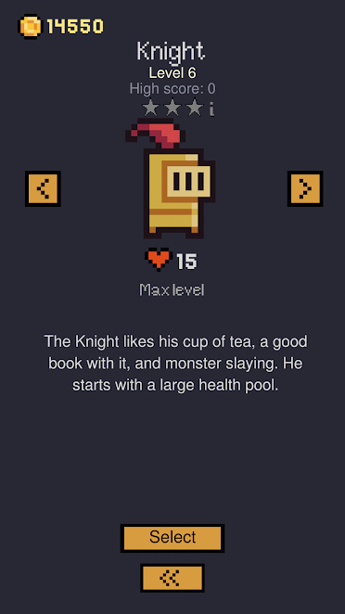

* *ITEMS*
  + Weapons (Provide additional HP to player shown in bottom-left)

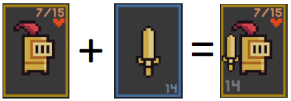

* + Money (in-game Currency)



* + Monsters & Traps (deals damage based on displayed value upon contact)

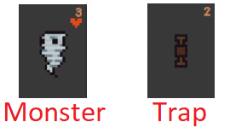

* + Potions (heals player by the displayed amount upon contact)



* + Powers (triggered when Money is obtained to certain amount)



* *ENVIRONMENT*
  + A 3x3 Card grid layout in 2D format

1. *Potion Maker*

* **PUBLISHER**: Sinsiroad  
  **OTHER GAMES PUBLISHED**: NONE
* **GENRE**: Idle-Clicker
* **DESCRIPTION**: Player as an alchemist assistant helps make potions to complete the incoming adventurers’ quests

**HOW TO PLAY**: Player would have to create potions to make money while completing quests (usually by making potions with specific potion levels) from adventurers before the time limit is over (Sinsiroad, 2016)as seen in ***FIGURE 1.06***.

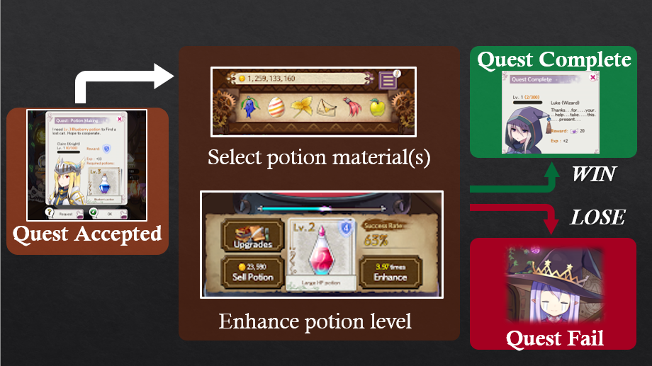

***FIGURE 1.06: General Overview of Potion Maker Gameplay***

In an example of a quest completion, the player would have to create a potion that has been requested by the client, in which the steps are as shown in ***FIGURE 1.07***.

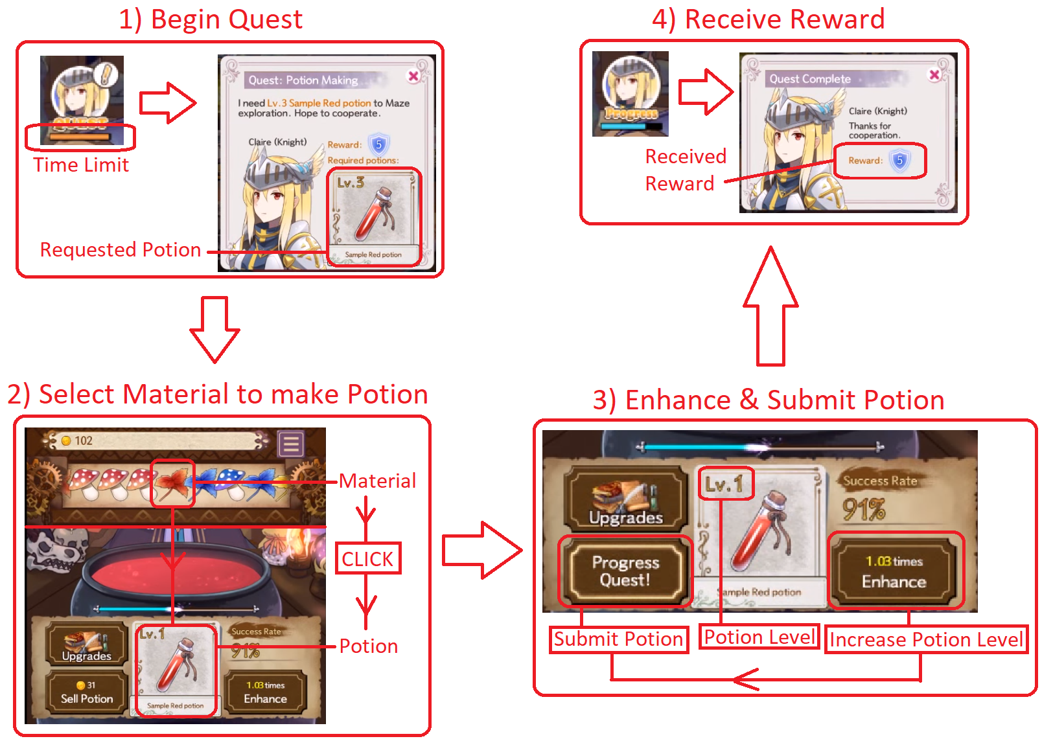

***FIGURE 1.07: Sample Gameplay of Quests in Potion Maker***

1. Quest is displayed with a time limit on the screen, showing details of rewards and wanted potions (with wanted potion level) when clicked on it.
2. Select suitable material to create the potion.
3. Enhance the potion to desired ‘potion level’ and send the finished potion to the client to progress quest.
4. Receive the rewards from completing the quest.

**WIN CONDITION**

* Successfully created the requested potion & send it to the client

**LOSE CONDITION** (for each quest)

* Time limit for the quest is over

**GAME MECHANICS**

* *CHARACTERS*
  + Player (invisible in this game)
  + In-game Avatars (Pio & Tia)
* *ITEMS*
  + Materials & Potions

|  |  |  |  |  |
| --- | --- | --- | --- | --- |
| **Material**  **Types** | **Potions**  **Created** | **Enhancement Success Rate** | **Selling**  **Price** | **Enhancement Amount to Max. Potion Level** |
| Red Items | Life Potions | Low | High | Less |
| Blue Items | Mana Potions | Medium | Medium | Medium |
| Yellow Items | Stamina Potions | High | Low | A Lot |

* + Money (usually spent on item OR feature upgrades)
  + Buffs (potion shield, enhance boost, sale boost)
    - **Potion Shield**: Prevents potion from being destroyed when enhance fails
    - **Enhance Boost**: Increases rate of success from enhancing potions
    - **Sale Boost**: Increases selling price of potions
* *ENVIRONMENT*
  + 2D ‘Alchemy Workshop’ background with a girl as in-game avatar display

1. *Dungeon & Girls: Card RPG*

* **PUBLISHER**: LUNOSOFT INC.  
  **OTHER GAMES PUBLISHED**: River City Ransom: Kunio Returns
* **GENRE**: Turn-based Card Adventure
* **DESCRIPTION**: An adventurer who explores in dungeons while recruiting girl partners.

**HOW TO PLAY**: Progress deeper into the dungeon using a deck of cards & defeat monster girls along the way (LUNOSOFT, 2016) as seen in ***FIGURE 1.08***.

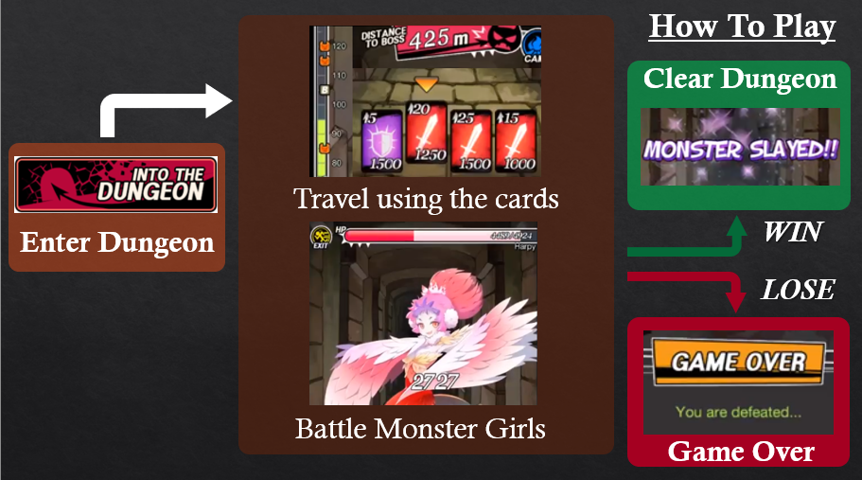

***FIGURE 1.08: General Overview of Dungeon & Girls Gameplay***

In an example gameplay of a dungeon level, the player would have to reach the end of dungeon using the cards randomly shuffled from the player’s deck as shown in ***FIGURE 1.09***.

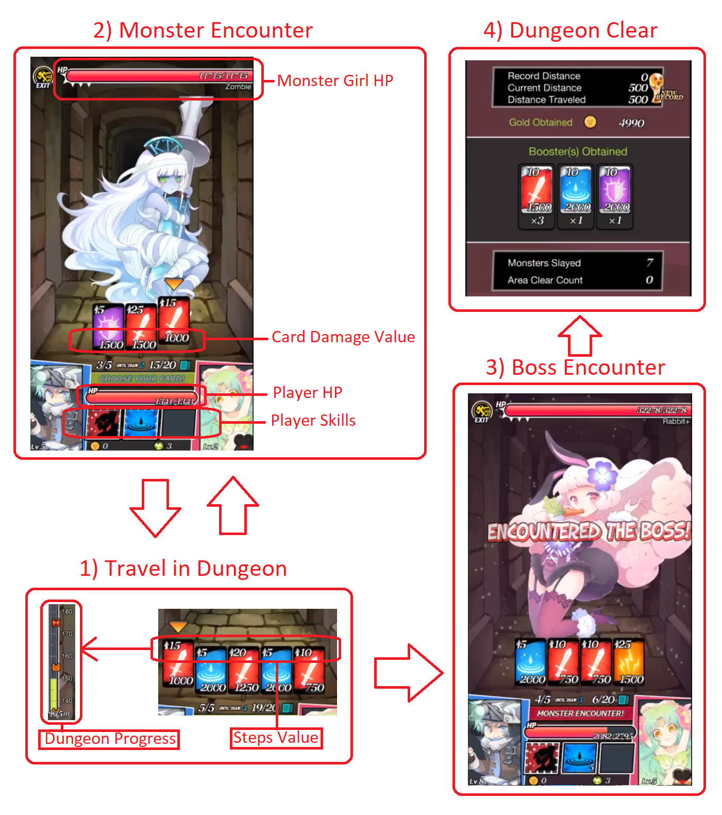

***FIGURE 1.09: Sample Gameplay of a Dungeon Level in Dungeon & Girls***

1. Use cards to advance through dungeon (card value determines steps taken)
2. When encountering monster girls, use the cards to battle (turn-based format)
3. Progress until reach the end of dungeon
4. Battle BOSS (monster girls too)
5. Defeat boss & clear dungeon

**WIN CONDITION**

* Completely travel the dungeon
* Defeat the dungeon boss at the end of dungeon

**LOSE CONDITION**

* When Player HP reaches 0

**GAME MECHANICS**

* *CHARACTERS*
  + **Player**: Has player skills to venture throughout areas
    - Has different classes that contains different cards ratio (e.g. 1:3:0:2)
  + **Girl Partner**: Provide player stat boost & extra attack
  + **Monster Girls**: Attacks player when in contact
    - When defeated, has a chance to join your team as partner
* *ITEMS*
  + Cards

|  |  |  |
| --- | --- | --- |
| **Card Image** | **Card Type** | **Effect** |
|  | Attack Card | Deals direct damage to opponent  (based on the card’s base value) |
|  | Counter Card | Reduce damage taken from opponent, and reduced amount would be dealt as direct damage to the opponent |
|  | Heal Card | Recovers player HP  (based on card’s base value) |
|  | Charge Card | Increases base value of all cards on next player turn only |

* + Player Skills: Varies between the Player’s class, but has 3 skill slots each
    - Effects: Extra attack, heal, direct damage, etc.
* *ENVIRONMENT*
  + 2D first-person view dungeon layout

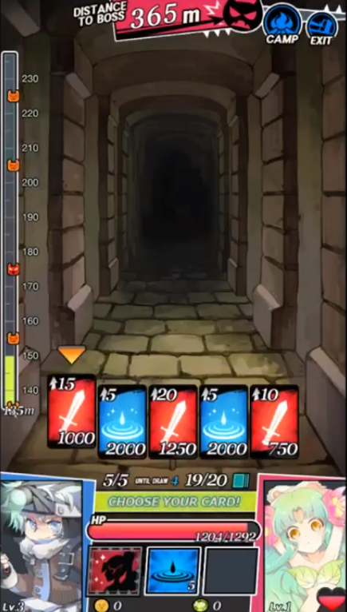

1. *Baldi’s Basics in Education & Learning*

* **PUBLISHER**: mystman12 (as itch.io game jam submission)  
  **OTHER GAMES PUBLISHED**: NONE
* **GENRE**: First-person horror
* **DESCRIPTION**: A student running away from teacher while collecting notebooks to escape from school as shown in ***FIGURE 1.10***.

**HOW TO PLAY**:

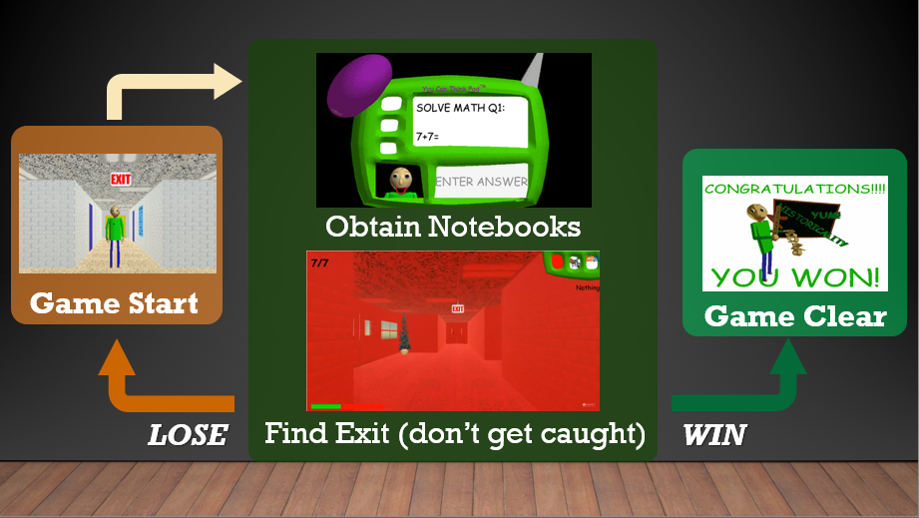

***FIGURE 1.10: General Overview of Baldi’s Basics in Education & Learning Gameplay***

In a demonstration of playing the game, the description of the steps of gameplay would be shown in ***FIGURE 1.11***.

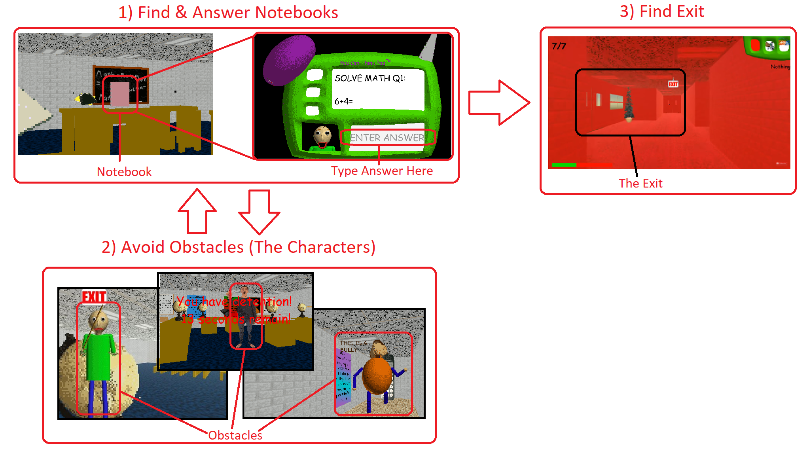

***FIGURE 1.11: Sample Playthrough of Bladi’s Basics of Education and Learning***

1. Find notebooks & Answer the questions in notebooks
2. Avoid any obstacles, including Bladi when collecting all 7 Notebooks
3. Find Exit after finding all 7 Notebooks

**WIN CONDITION**

* Obtained all 7 Notebooks, answer all questions & find exit (unlocks normal ending)
* Purposely answer all Notebooks’ questions **wrong** and find exit (unlocks ‘true’ ending)

**LOSE CONDITION**

* When get caught by teacher ‘Baldi’ (mystman12, 2018)

**GAME MECHANICS**

* *CHARACTERS*
  + Usually just obstacles, in multiple forms (other than the player)

|  |  |  |
| --- | --- | --- |
| **Character Image** | **Character Name** | **Feature(s)** |
|  | Baldi | Instantly triggers GAME OVER when in contact (after answering **wrong** once in the notebook) |
|  | 1st Prize | Follows player and pushes any characters in contact |
|  | Playtime | Triggers a jumping minigame that lasts for at least 10 seconds, stopping player’s motion in the meantime |
|  | It’s a Bully | Blocks the player’s path unless it steals 1 item from the player’s inventory |
|  | Gotta Sweep | Moves in independent path and pushes anything in contact |
|  | Arts and Crafts | Teleports the player and Baldi to the starting location of the game (school entrance) when in contact.  (after player obtains all 7 notebooks) |
|  | Principal of the Thing | Traps player in a ‘Detention Room’ for 15 seconds whenever it catches the player ‘running’ in the school. |

* *ITEMS*
  + Can be used to stop teacher ‘Baldi’ from chasing temporarily
  + Or speed up player movement, reduce/remove obstacles, etc.
* *ENVIRONMENT*
  + 3D environment featuring ‘crappy’ 90’s education programs and applications

## Game Reviews: LIM ZHI DA

1. *INSIDE*

* **Publisher:** Playdead
* **Genre:** Puzzle-platformer, adventure
* **Description:** An adventure of a boy who may run, climb and control object to surpass challenges, but also may die due to different condition (Playdead, 2018).

**How to play:** Control the character to use/move object to overcome obstacles, avoid the enemy and figure out the way like moving certain object to certain point to proceed further.

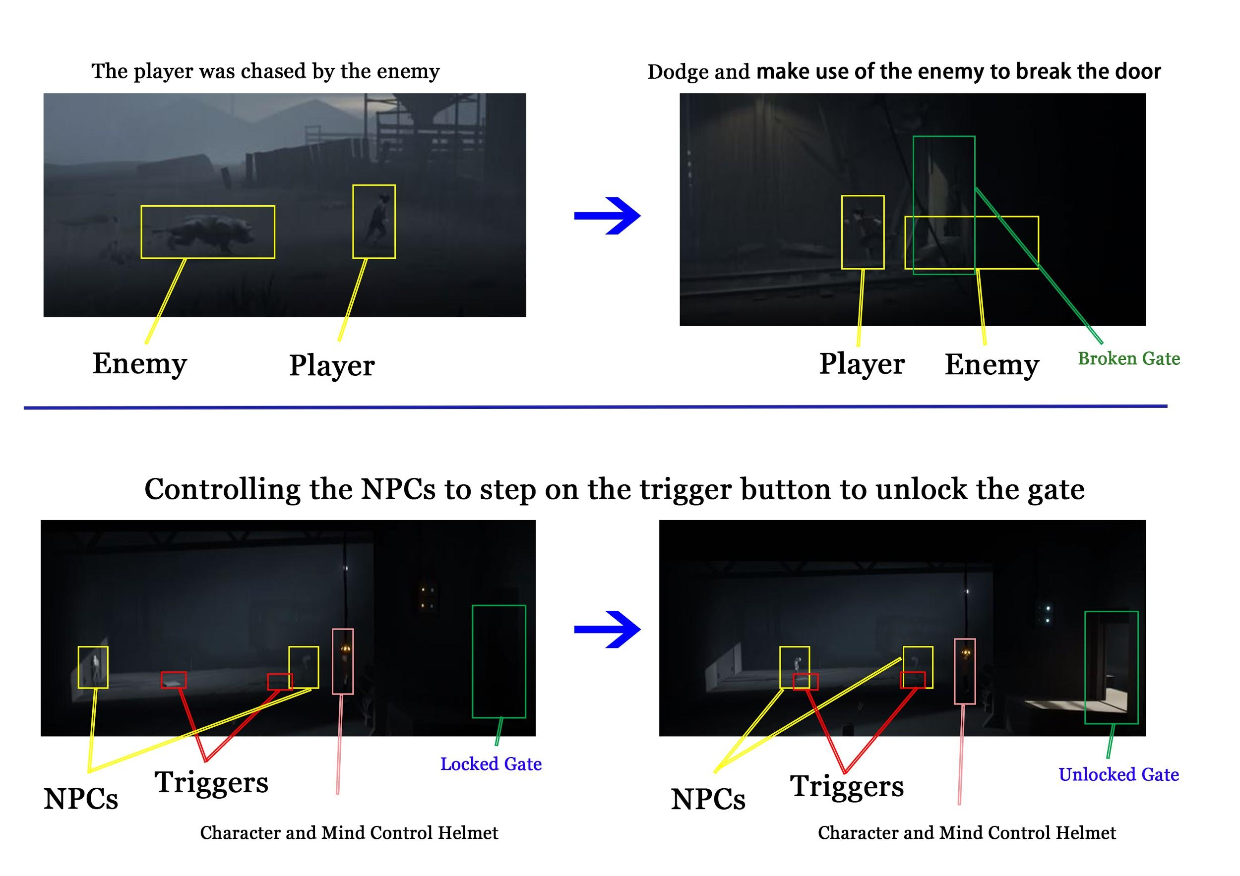

***FIGURE 1.12: Showing two examples of solving the puzzles in game***

Easter eggs and hidden collectibles are available in the game too, they’re not affecting the main gameplay but adding the replay value of the game.

* **Winning Condition:** Escape from the forest successfully.
* **Losing Condition:** Get caught by enemies (dogs, guards etc).

**Game Mechanics**

* **Character:** A boy
* **Item:** Animals, Zombie-like people, Mind-control Helmet
* **Environment:** A forest with road and incline, Office and Laboratories

1. *Samsara*

* **Publisher:** Marker Limited
* **Genre:** Puzzle-platformer
* **Description:** Helps an innocent child escape to the destination point, by moving the provided blocks that come with different shape into two mirrored world which separated by the surface of a pool (MarkerLtd., 2018).

**How to play:** Select, rotate, and place the blocks to create a path to the exit.

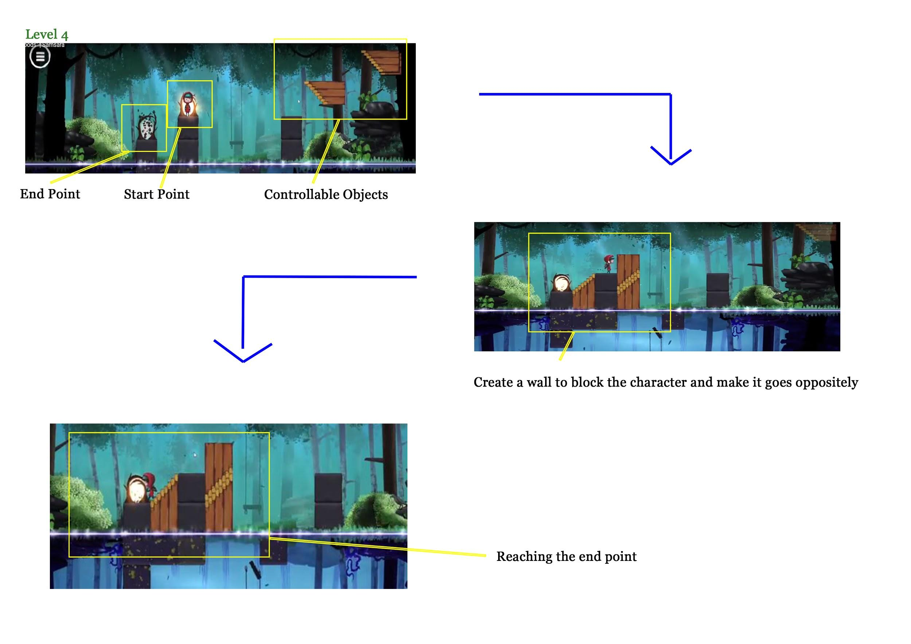

***FIGURE 1.13: Samsara Chapter 2 Level 4***

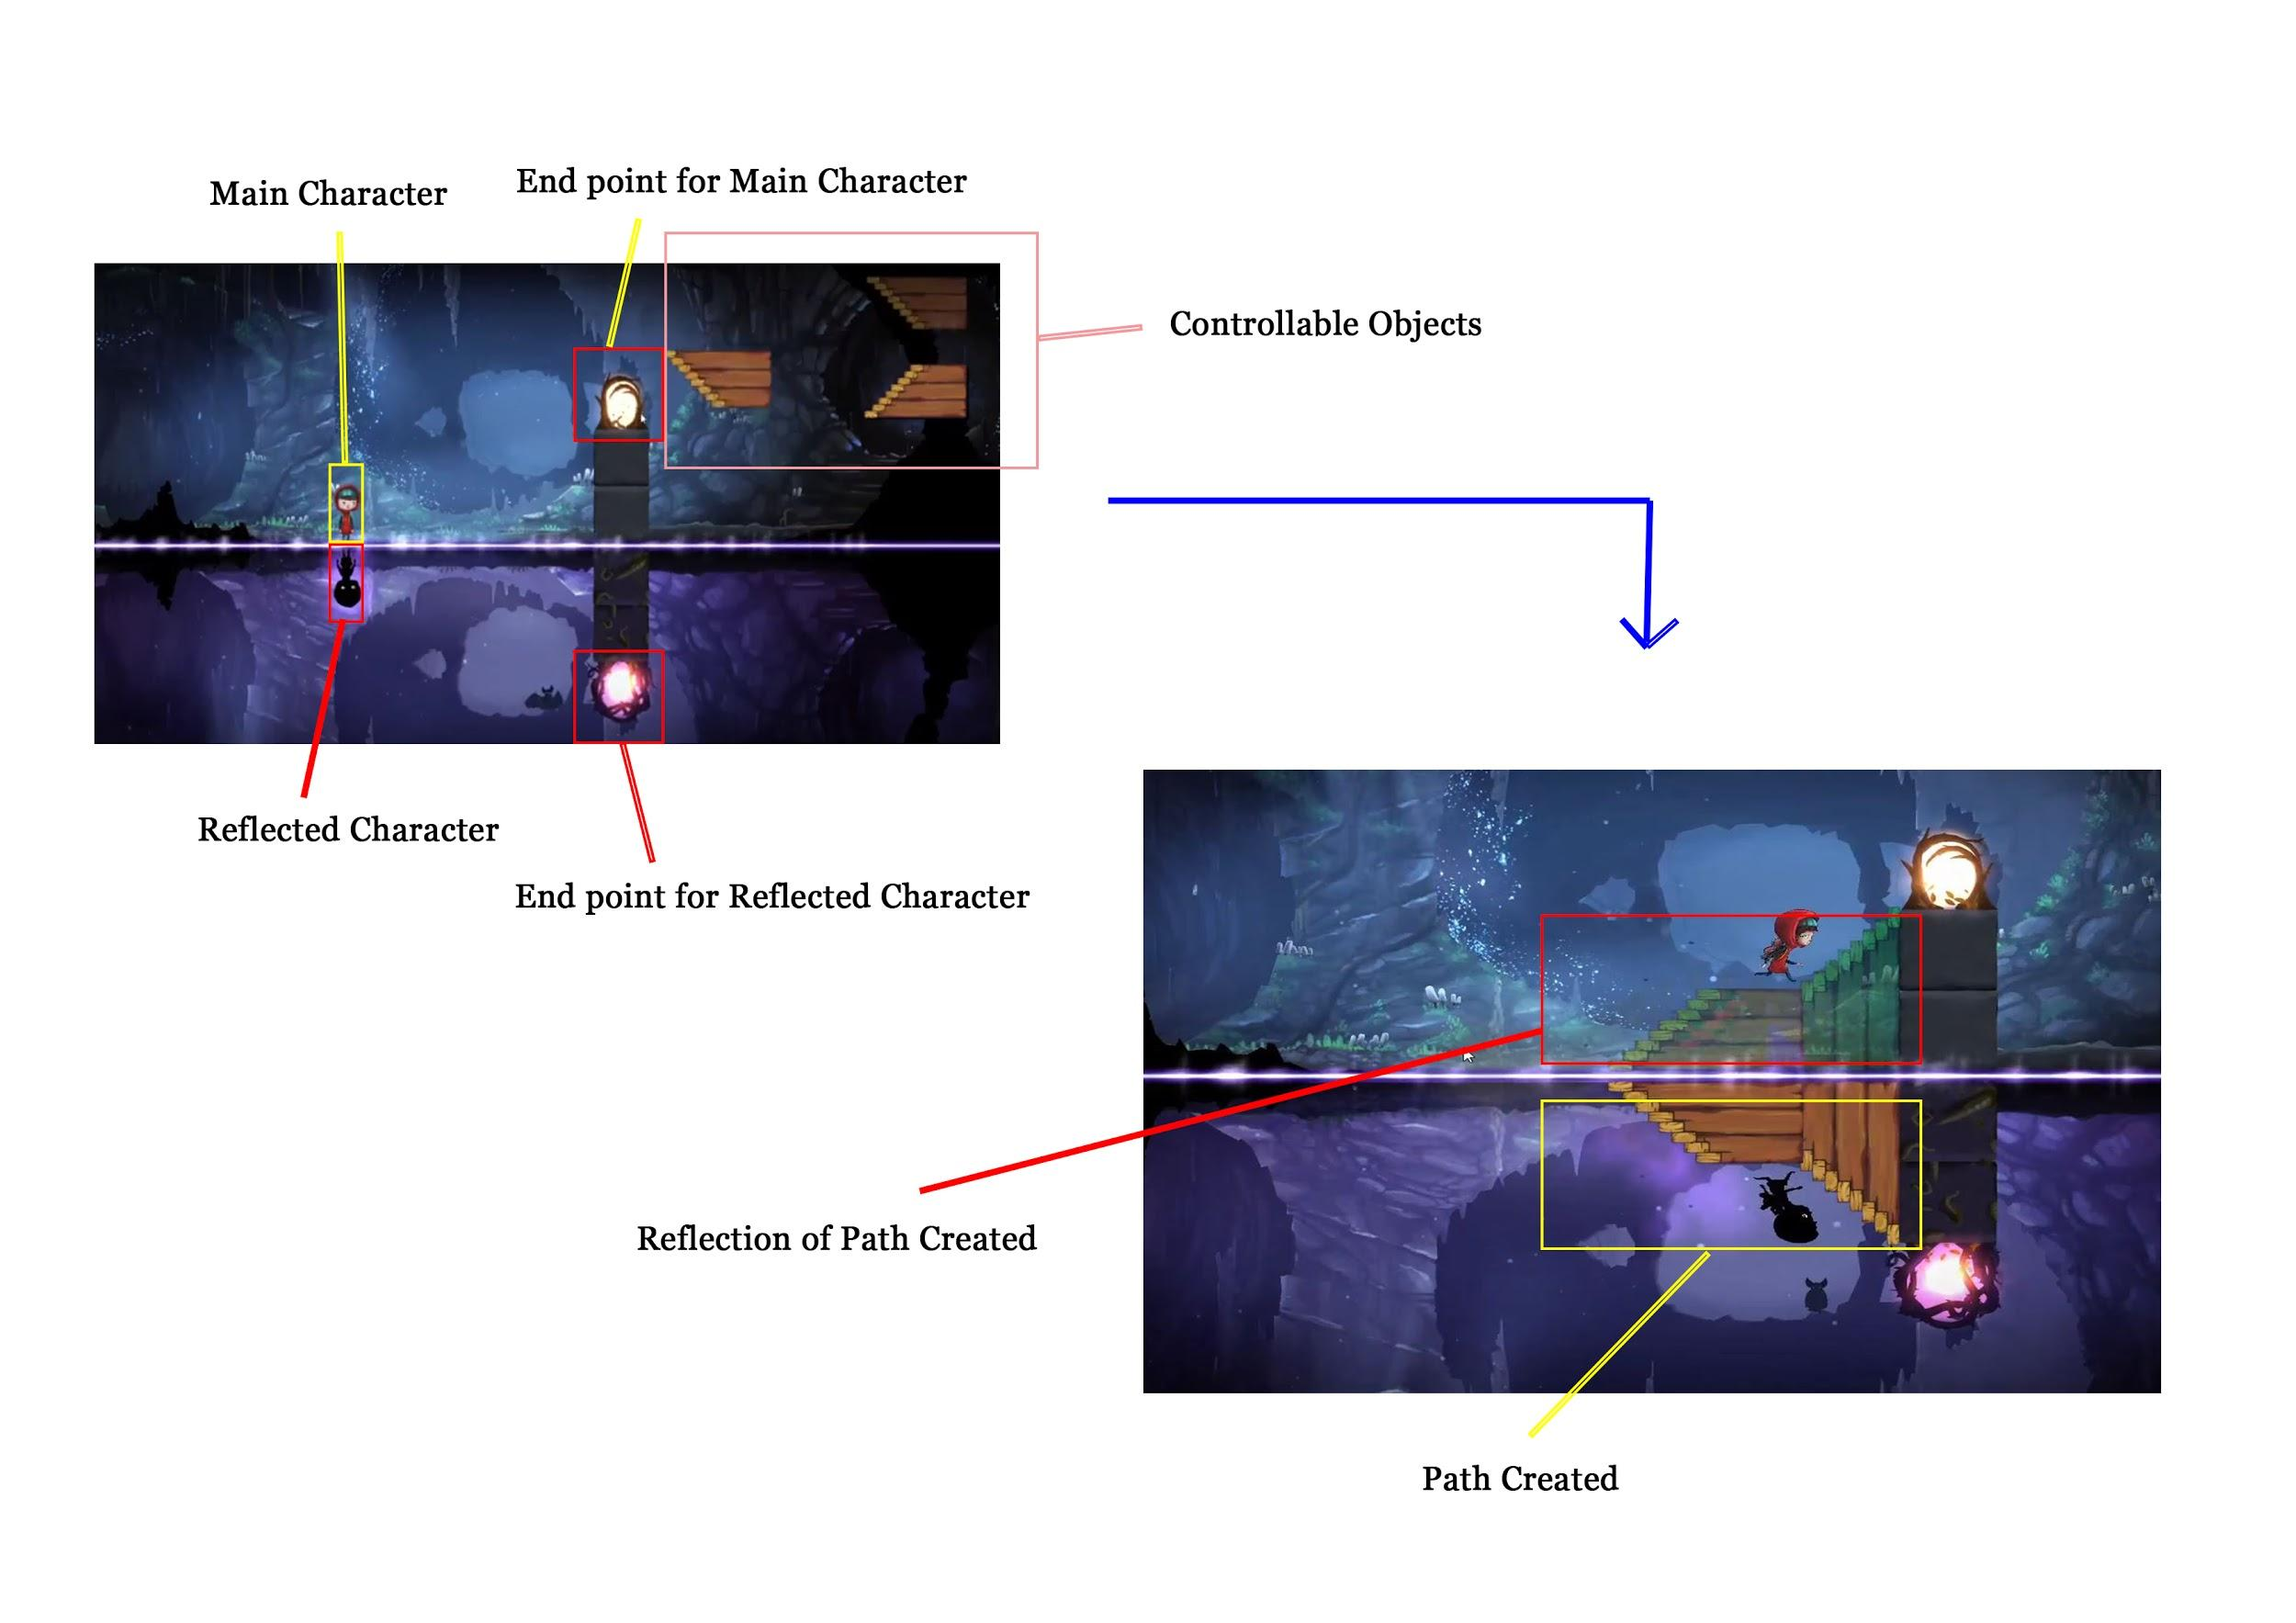

***FIGURE 1.14: Samsara Chapter 3 Level 1***

* **Winning Condition:** Unlock the correct path for the children to reach the escape point.
* **Losing Condition:** Placed the blocks wrongly, which fails the children from escaping.

**Game Mechanics**

* **Character:** Vary kind of Blocks
* **Item:** Portals, dark root.
* **Environment:** Mirrored dimensions.

1. *Snipperclips*

* **Publisher:** SFB Games
* **Genre:** Co-operative Puzzle game
* **Description:** Players control two character which may rotate and moving around the level. One player may snip the overlapping part of another player to create certain shape for solving the puzzle.

**How to play:** Players may overlap each other to snip the intended shape to move/unlock the puzzle or jump on another player to move to a higher platform (Games, 2018).

* **Winning Condition:** Solve the puzzle.
* **Losing Condition:** Failed to solve the puzzle.

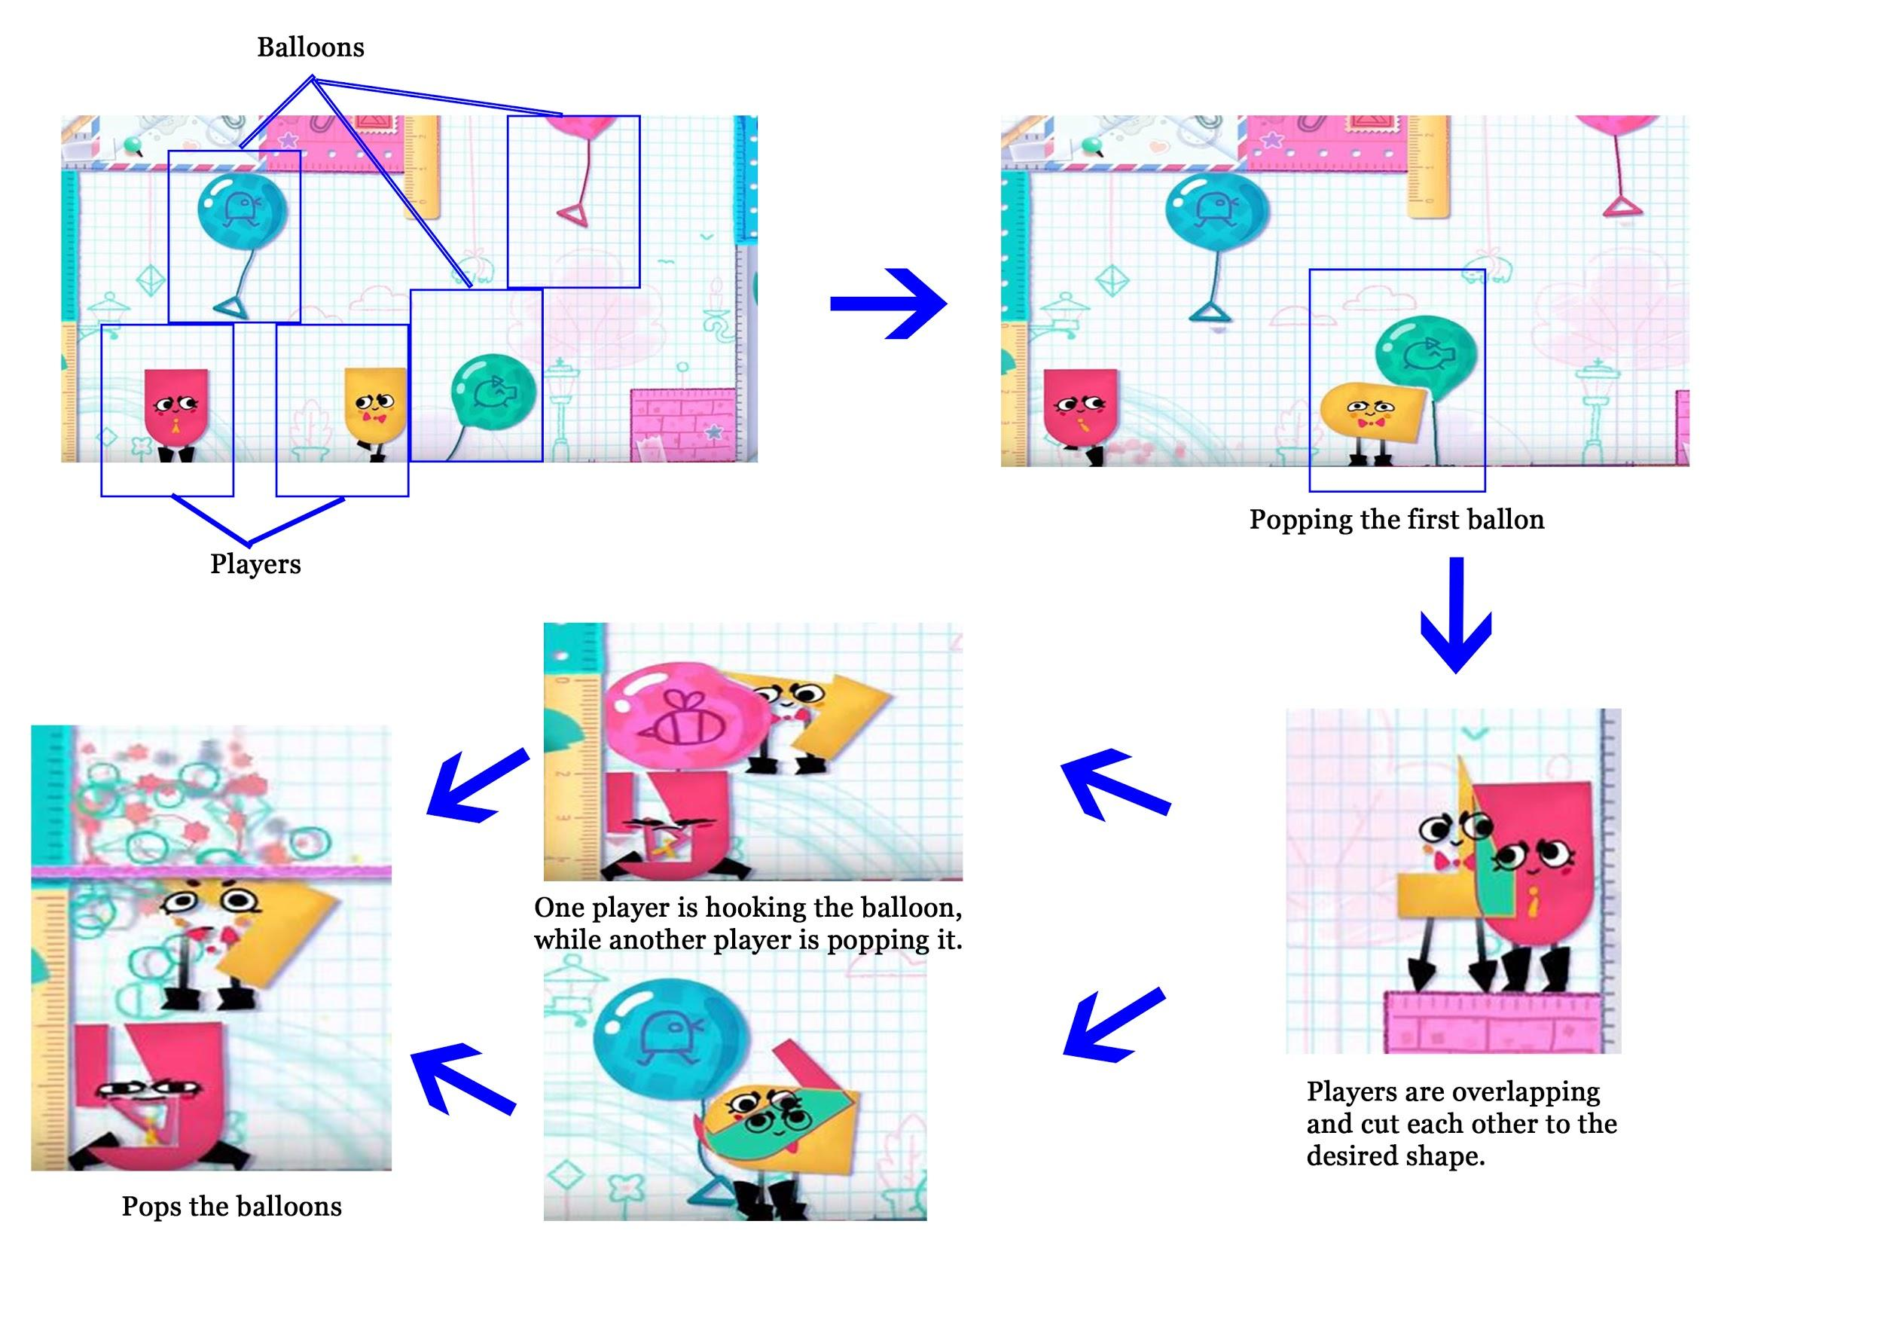

***FIGURE 1.15: Level - Balloon Burster***

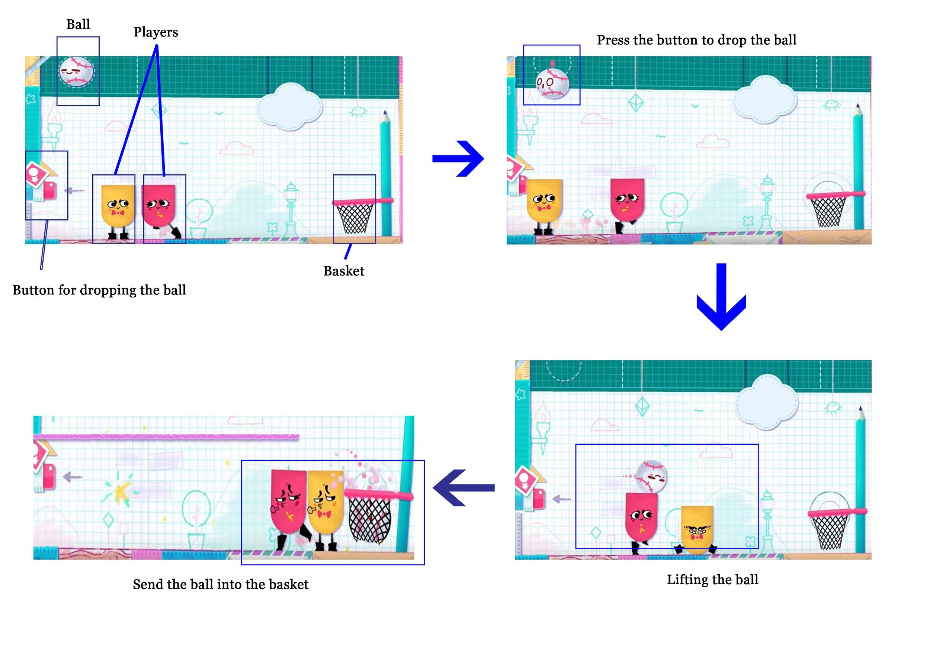

***FIGURE 1.16: Level - Baseballin'***

**Game Mechanics**

* **Character:** Paper Character(s)
* **Item:** -
* **Environment:** 2D platform with background that comes along with stationary.

1. *Lara Croft Go*

* **Publisher:** Square Enix
* **Genre:** Turn-based puzzle video game
* **Description:** Move the character turn by turn in the map which is unit based, clearing the level by eliminating enemies or manipulate the scene to solve a certain puzzle (Enix, 2018).

**How to play:** Controls the character to move or climb in the horizontal plane and vertical platform such as cliff, while the enemies and the environment are also taking the turn to move.

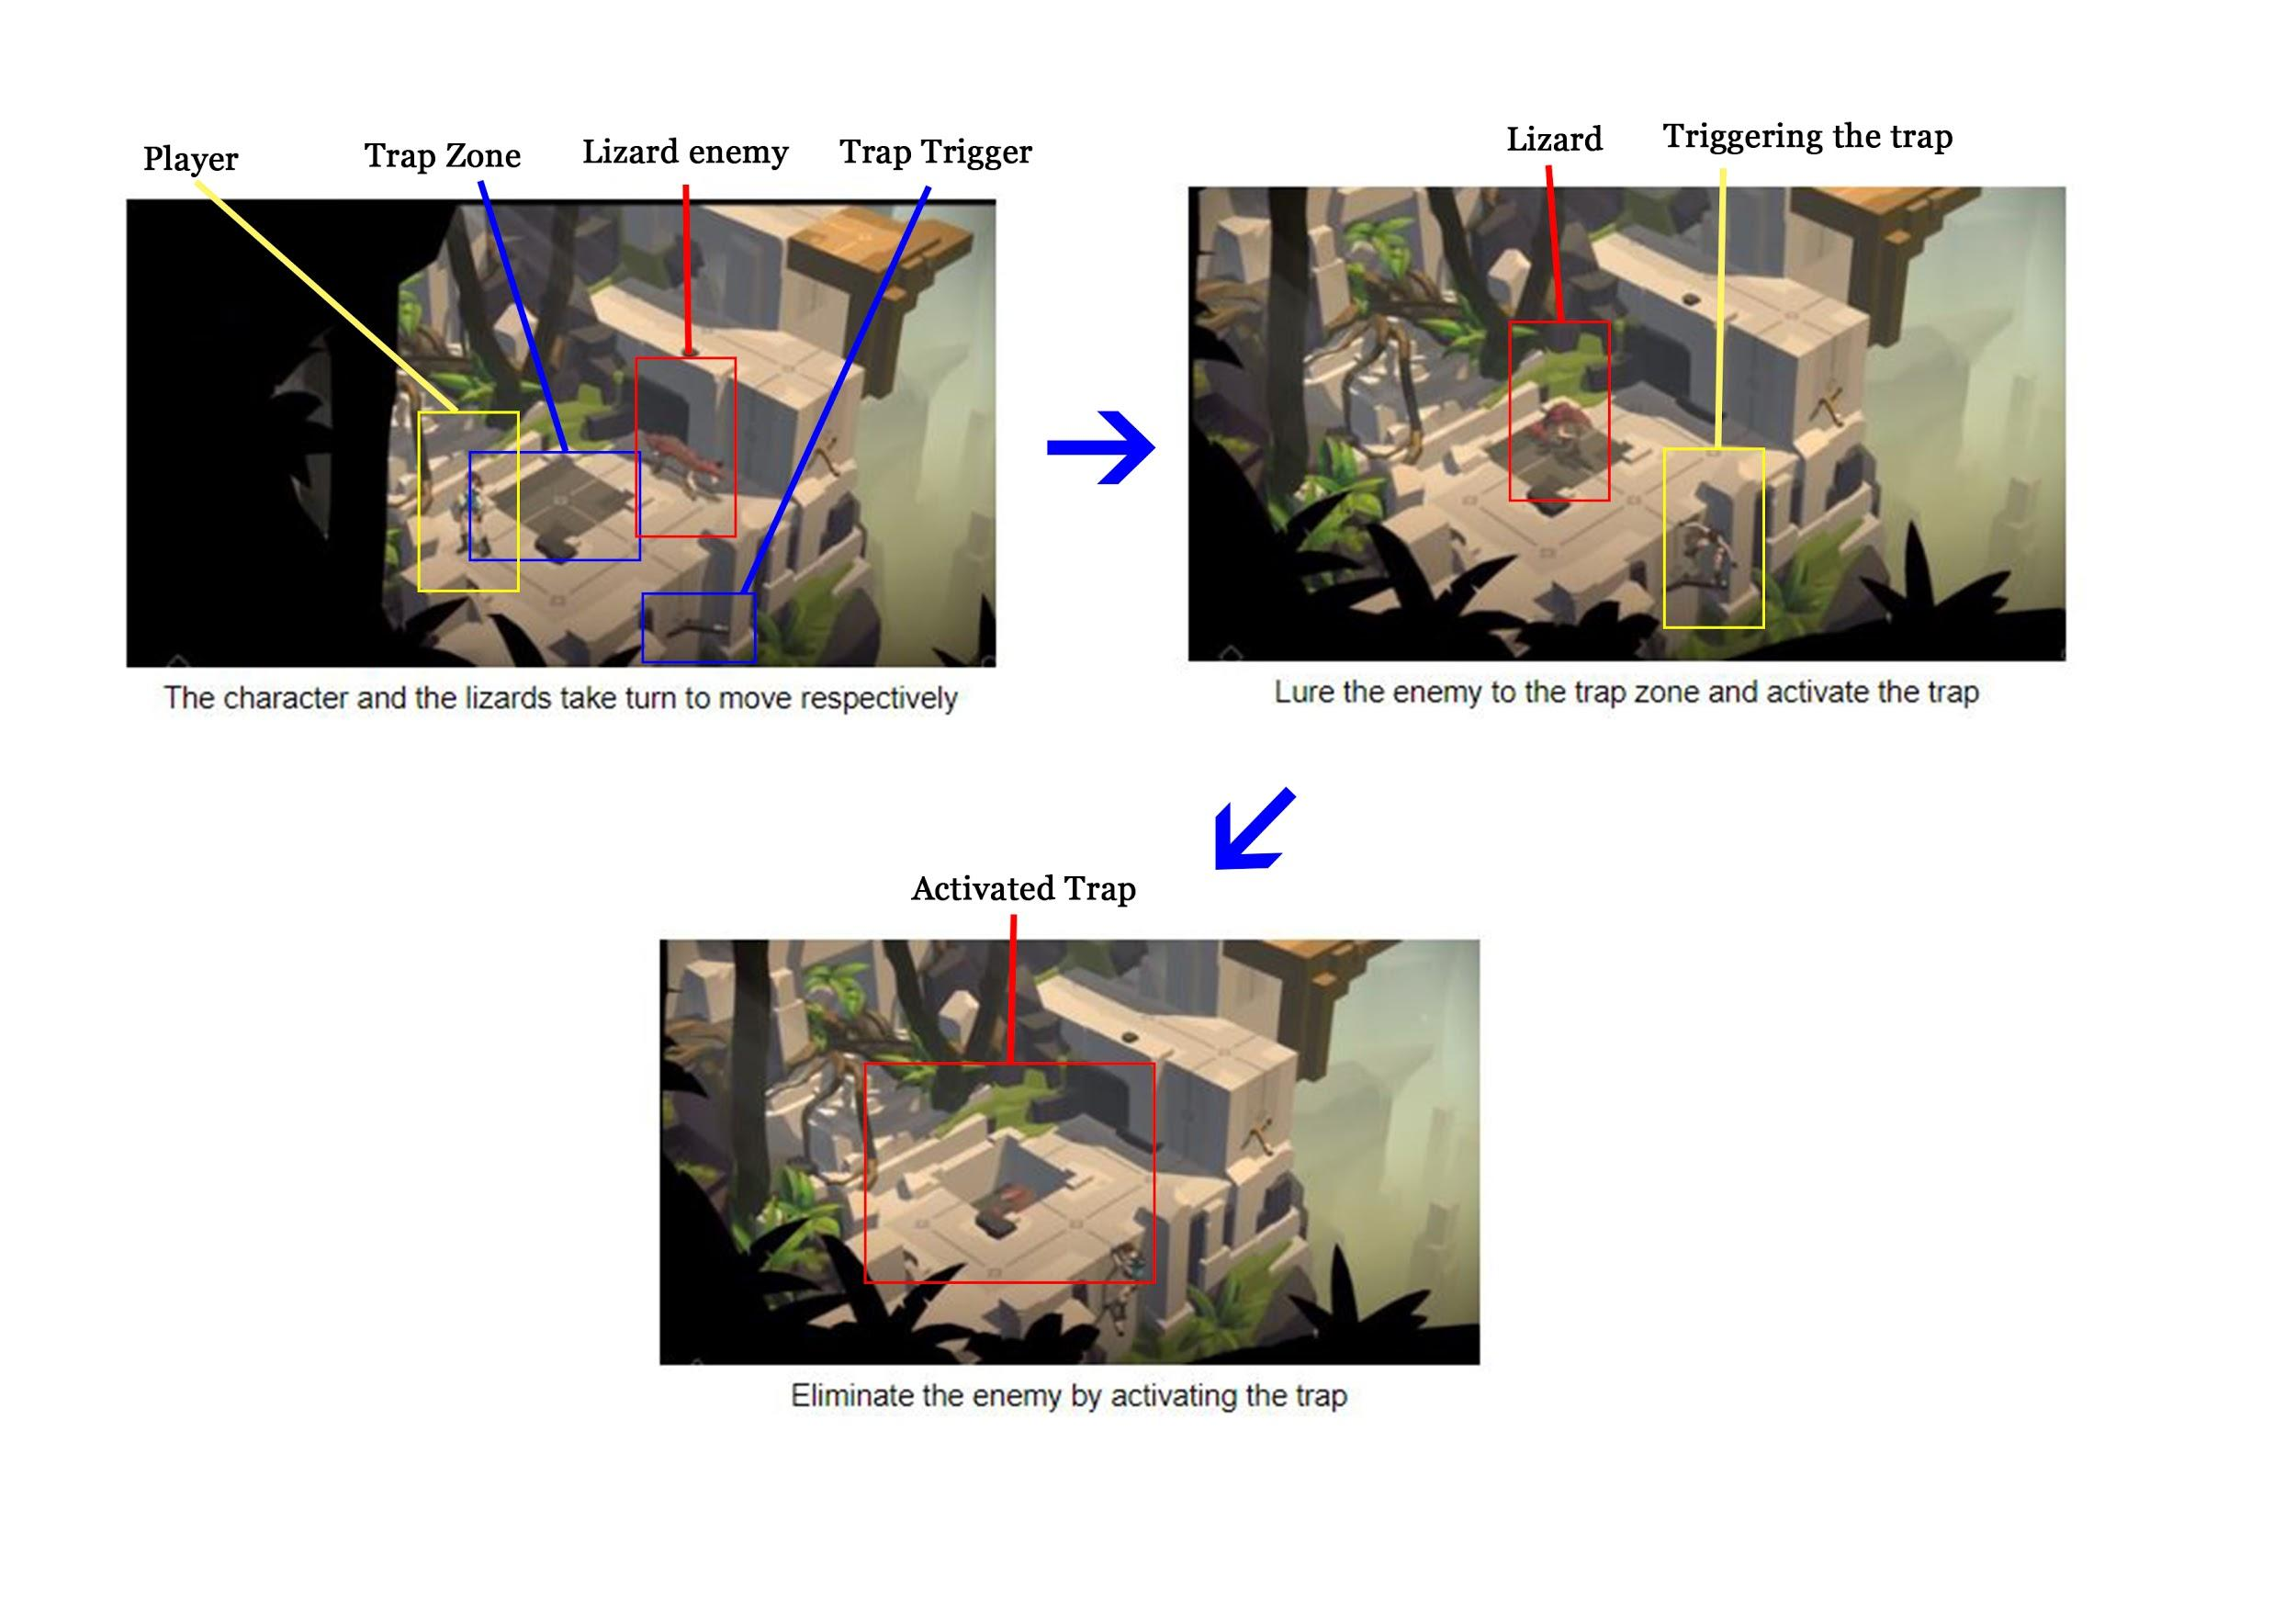

***FIGURE 1.17: Puzzle Example 1***

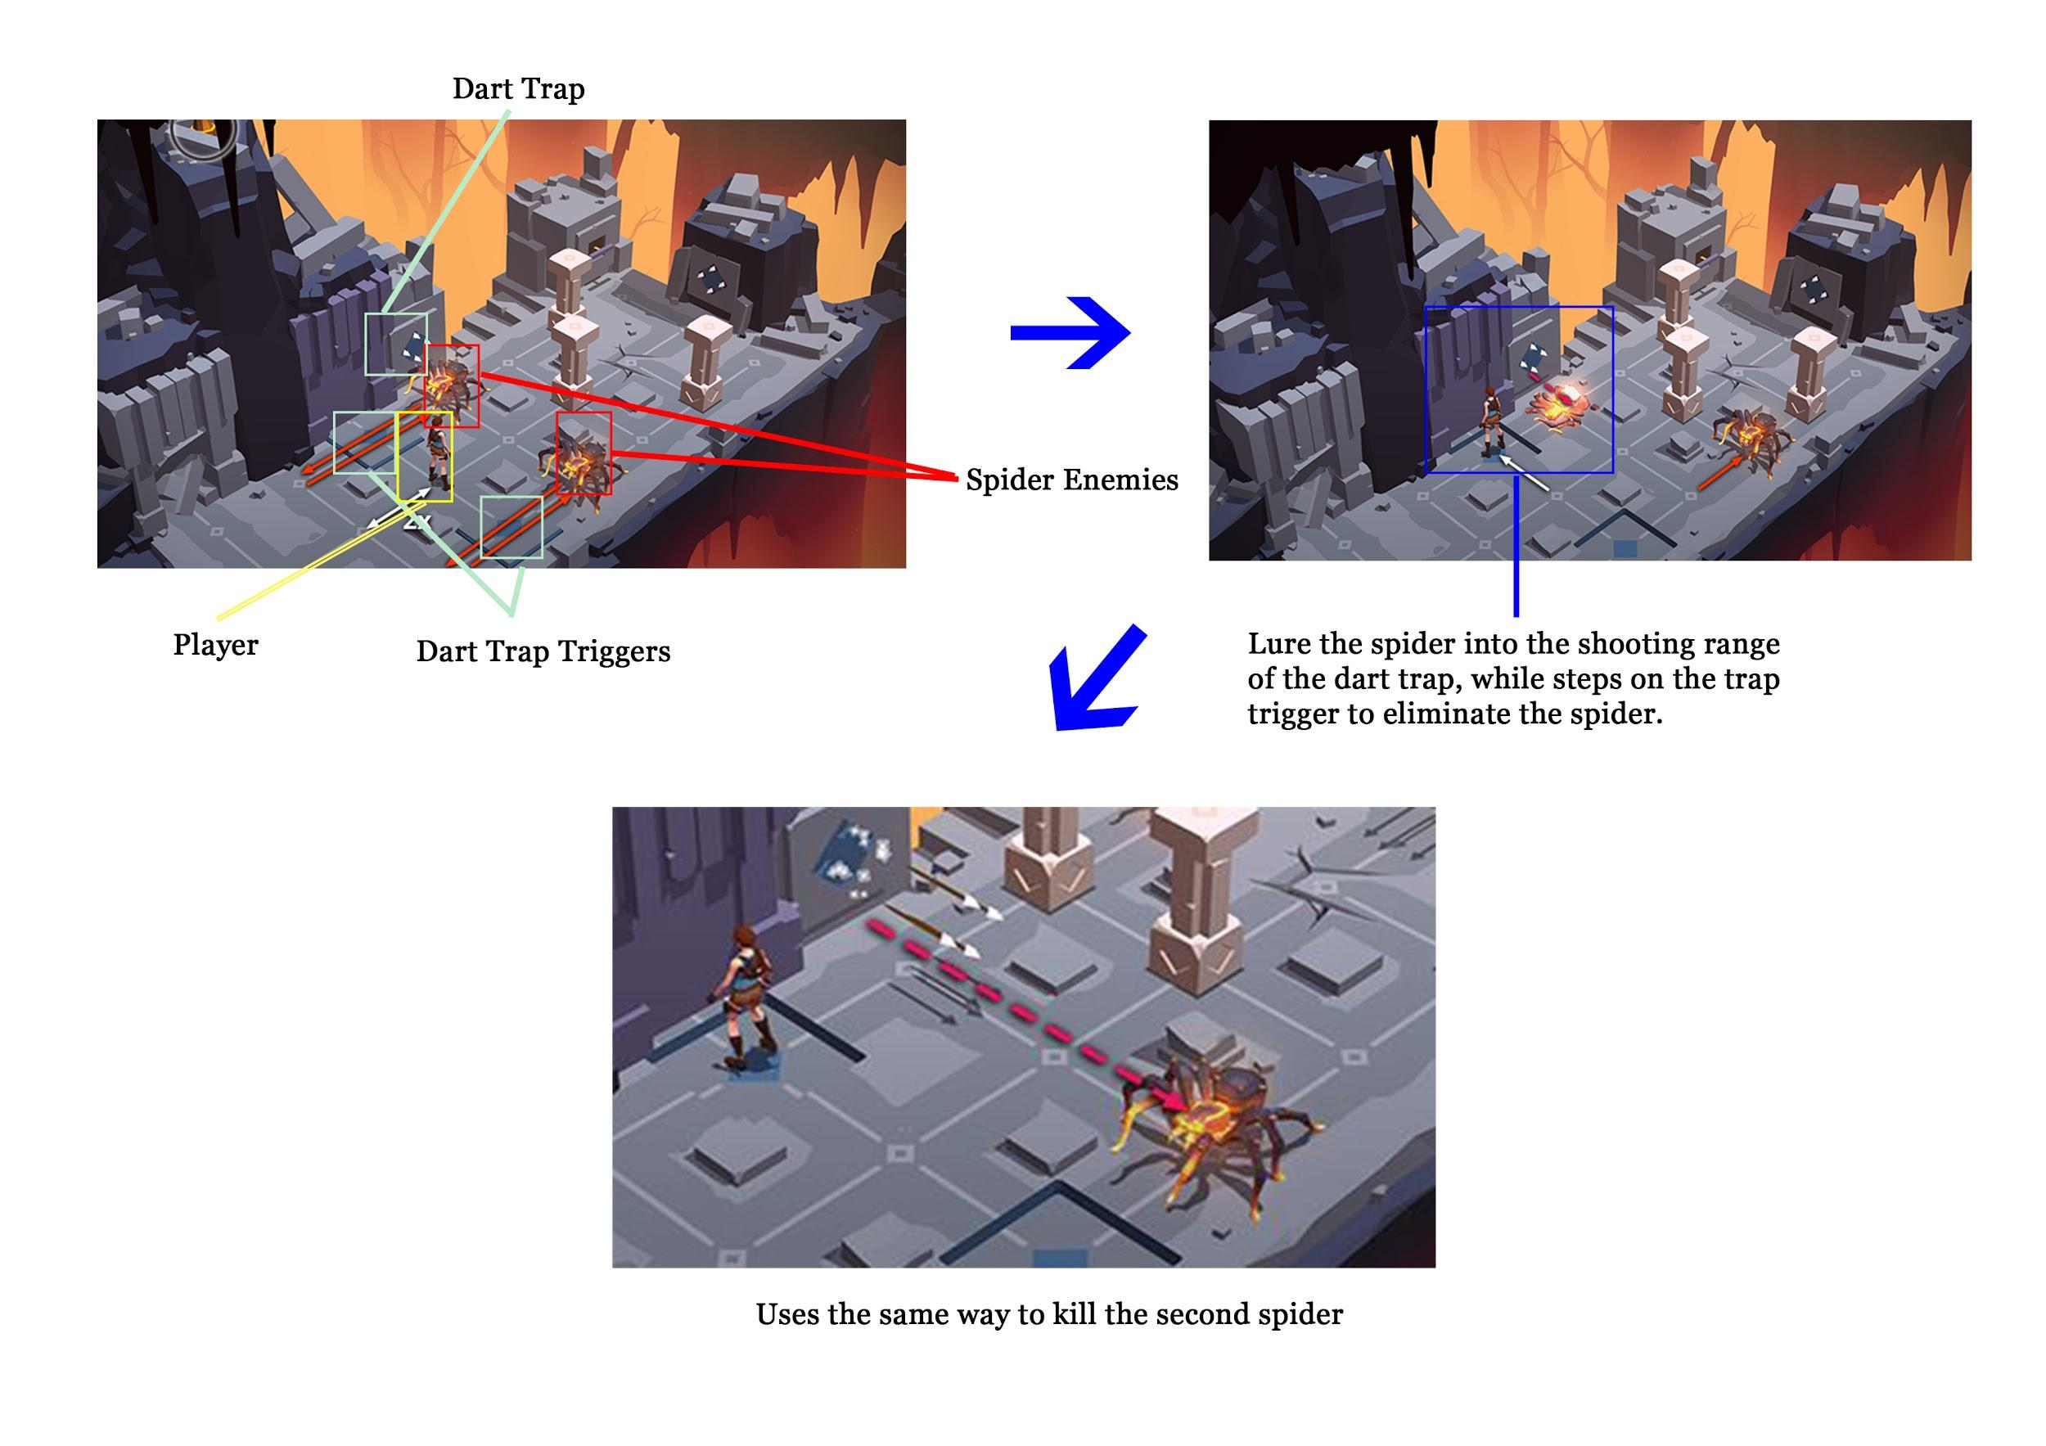

***FIGURE 1.18: Puzzle Example 2***

* **Winning Condition:** Avoid the enemy and reach the checkpoint of the level.
* **Losing Condition:** Collided with enemy or falls into the trap.

**Game Mechanics**

* **Character:** Lara Croft
* **Item:** Spear, Traps
* **Environment:** Valley with traps and trap triggers, cliff.

1. *The Witness*

* **Publisher:** Thekla, Inc.
* **Genre:** 3D puzzle video game
* **Description:** Solves multiple kinds of puzzle and explore the maze in the island.

**How to play:** Draw a correct path in the puzzle grid to solve the puzzle, usually the hints for the puzzle would appear in the environment.

* **Winning Condition:** Solve the puzzle in the checkpoint and proceed to another section of the island (Thekla, 2018).
* **Losing Condition:** -

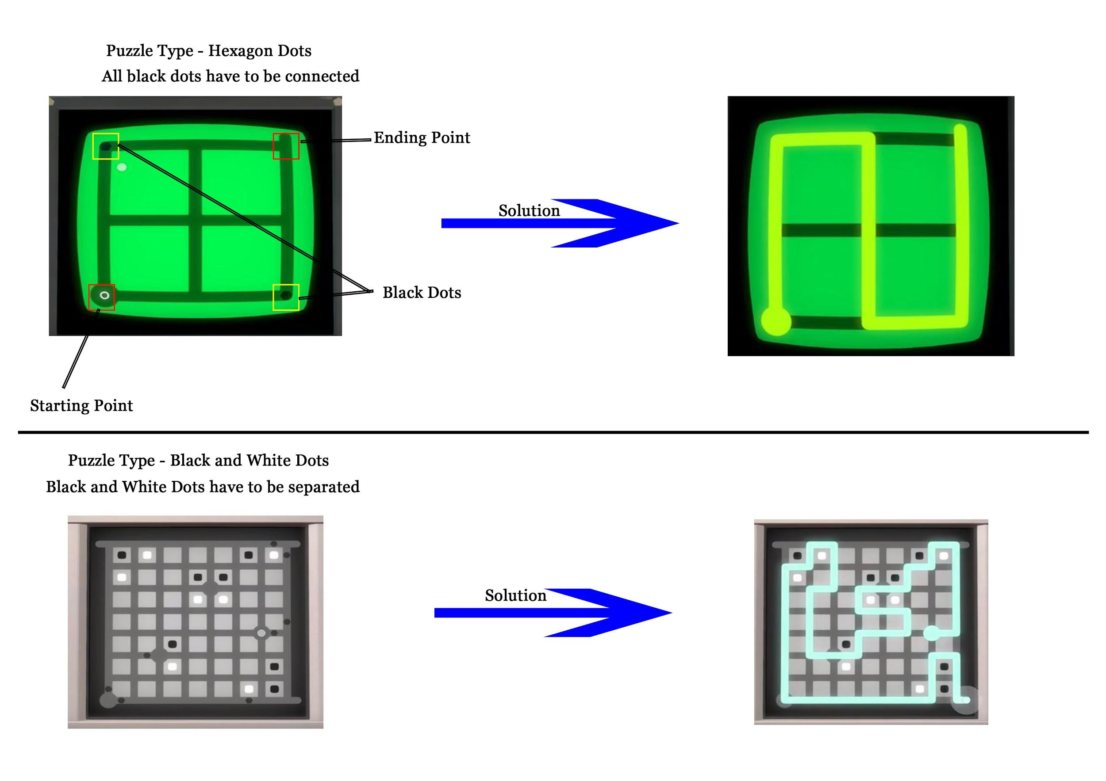

***FIGURE 1.19: Puzzle type samples 1 and 2 in The Witness***

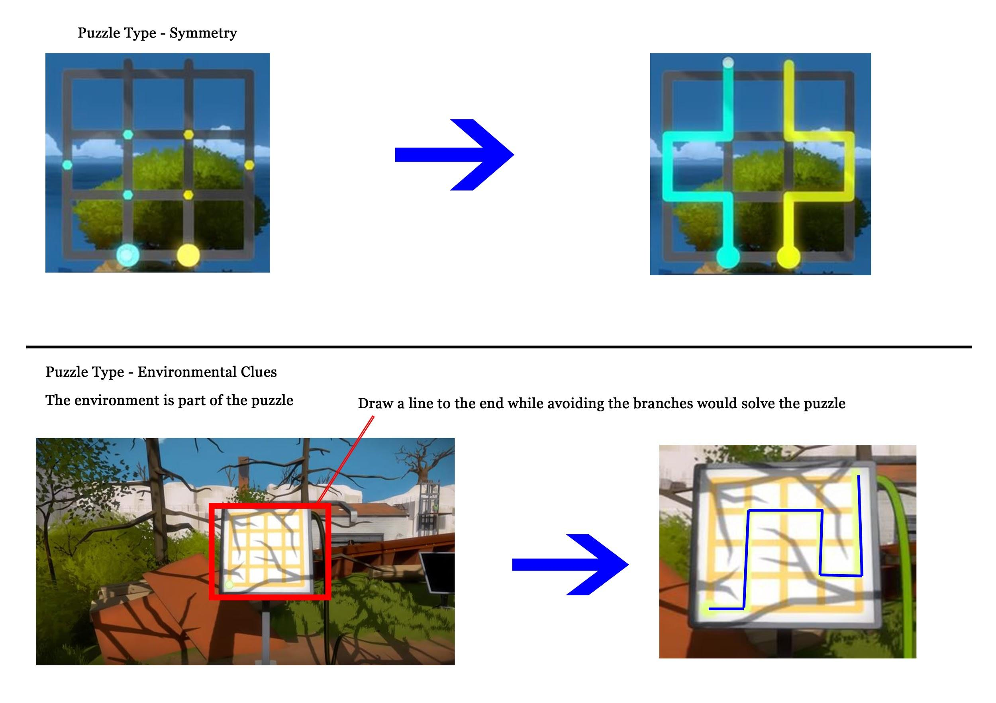

***FIGURE 1.20: Puzzle type samples 3 and 4 in The Witness***

**Game Mechanics**

* **Character:** An unnamed character
* **Item:** -
* **Environment:** Island with a lot of locked gate which requires puzzle solving to unlock.

## Game Reviews: SEE RONG JIE

1. *Mekorama*

* **Publisher**: Martin Magni
* **Genre**: Puzzle
* **Description**: Help a tiny robot to find home through 50 puzzling mechanics three-dimensional scene (Magni, 2017)

**How to play**: Swipe left and right to see the scene, tap to let robot move to that point, reach the red dot spot to end a level

**Win condition:** Guide the robot to reach red end dot.

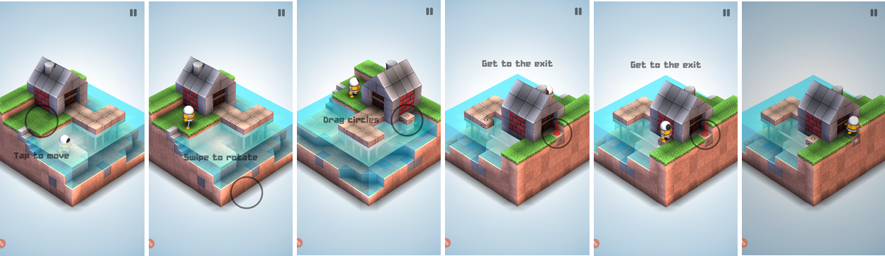

**Lose condition**: Restart the stage if end up in these kinds of situation, shocked by electric or leave the puzzle.

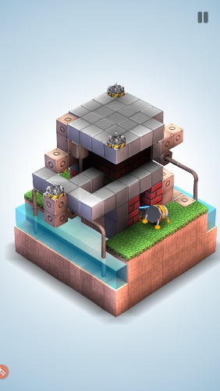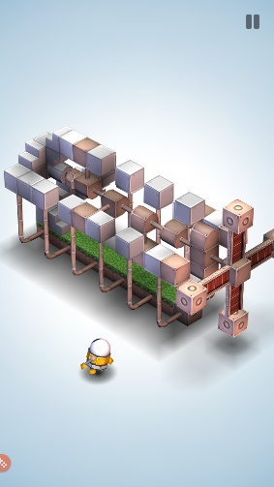

**Game Mechanics**

* **Character**: Tiny robot and AI robot

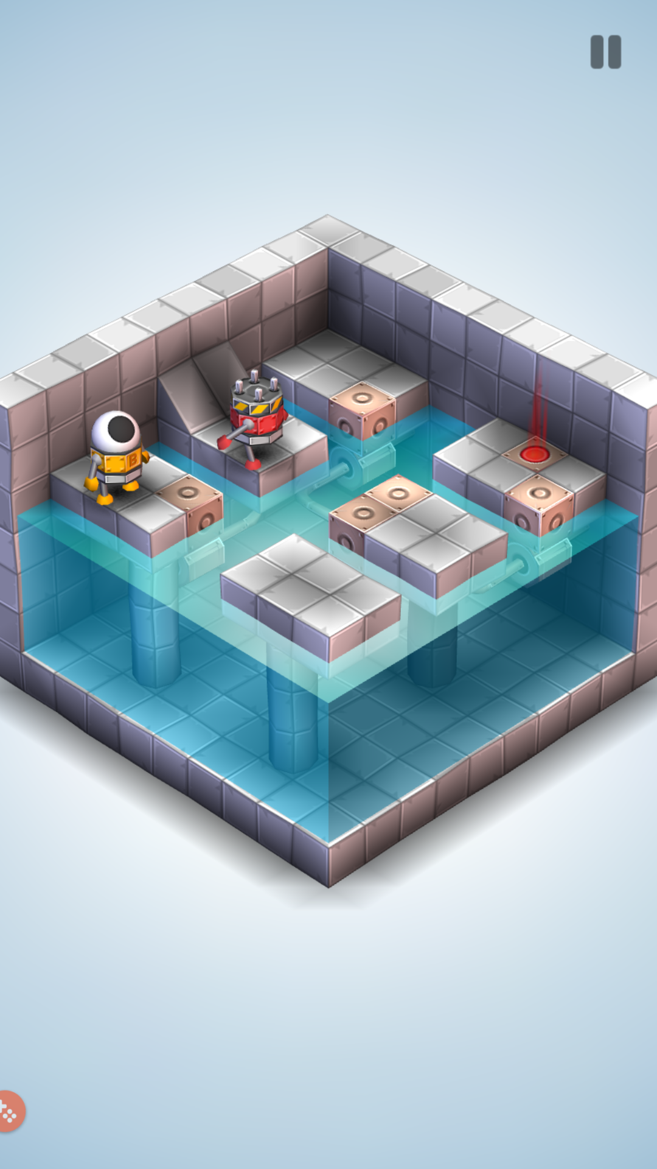

* **Items**: the only movable item is the cube with circle on it



* **Environment**: 3D environment using blocks to create path, water, traps and buildings. Excellent level design using puzzle elements

1. *Monster Strike*

* **Publisher**: Mixi
* **Genre**: Turn Based Puzzle RPG
* **Description**: Combat system by using slingshot-style to throw characters in a closed area thus let them bounce around, activate abilities while dealing damage to monsters

**How to play**: Drag, pull and release the character to bounce and damaged the monsters to clear a stage (Mixi, 2015)

**Win Condition**:

* Each character has their own attack, health, speed, skills, passive ability and active ability
* Choose the marbles that are suitable or counter the stage
* Adjusting the angle and direction to shoot and try to kill the enemies
* Player won when defeated the boss

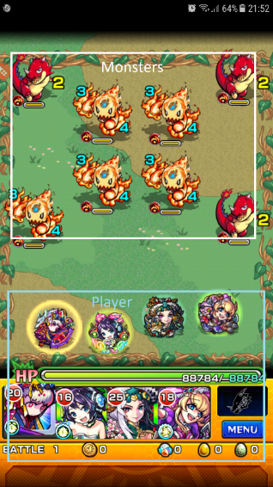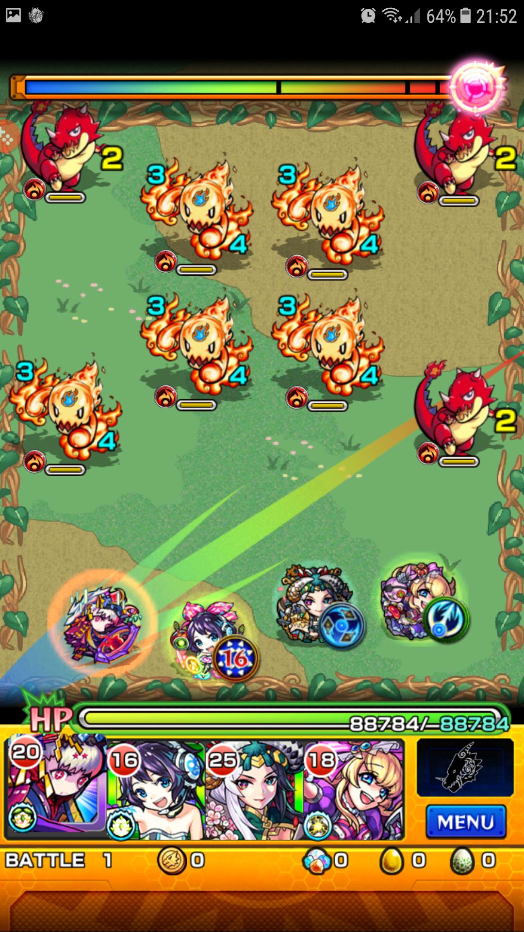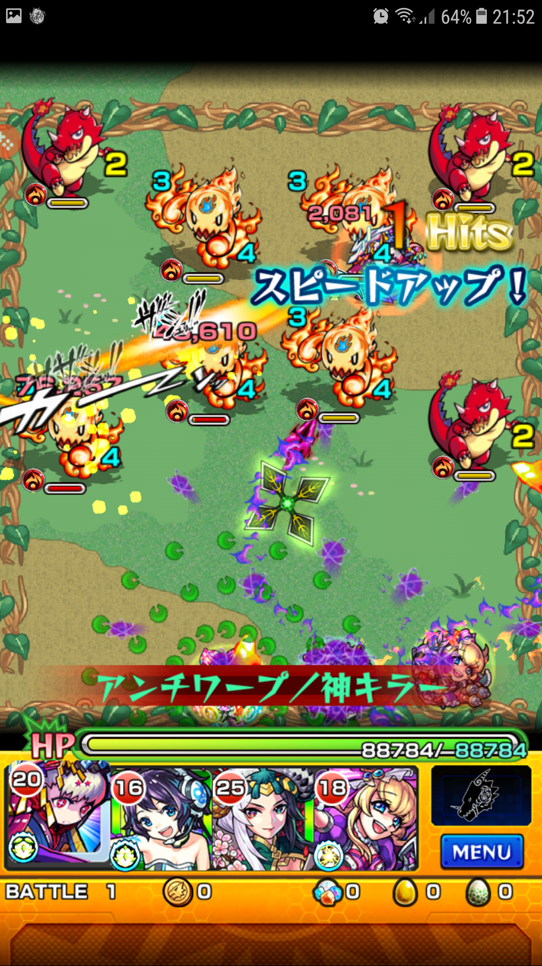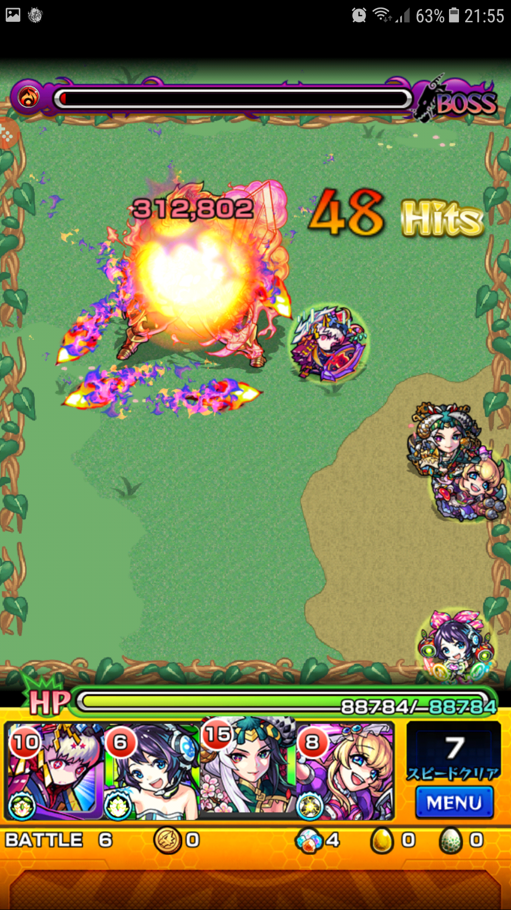

**Lose Condition:**

* Health drop to 0

**Game Mechanics**

* **Character**: 4 marble characters, monsters
* **Item**: heart, sword, boots, hourglass, radar etc
* **Environment**: Rectangle enclosed area and placement of enemies and traps

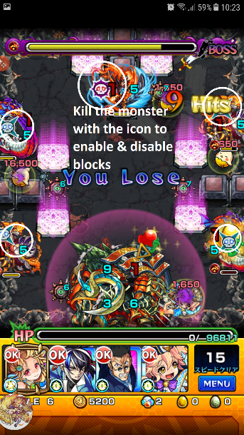 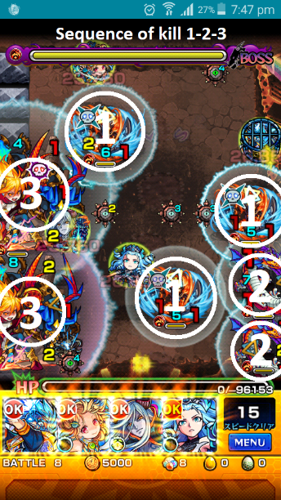 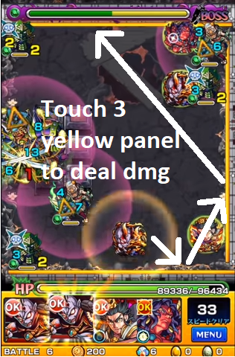

As game goes on, the level will become very difficult as player can only bring some specific characters, even the level has certain sequence to play through or else it cannot even hurt the boss. Moreover, even the angle has to be perfect as well in order to pass the stage.

1. *Causality*

* **Publisher**: Loju
* **Genre**: Puzzle
* **Description**: Help a group of stranded astronauts find a route to safety across alien landscapes, manipulating time and solve paradoxes in this time bending puzzler (Loiu, 2018)

**How to play**:

**Win condition**: Guide the astronauts to their respective color panel

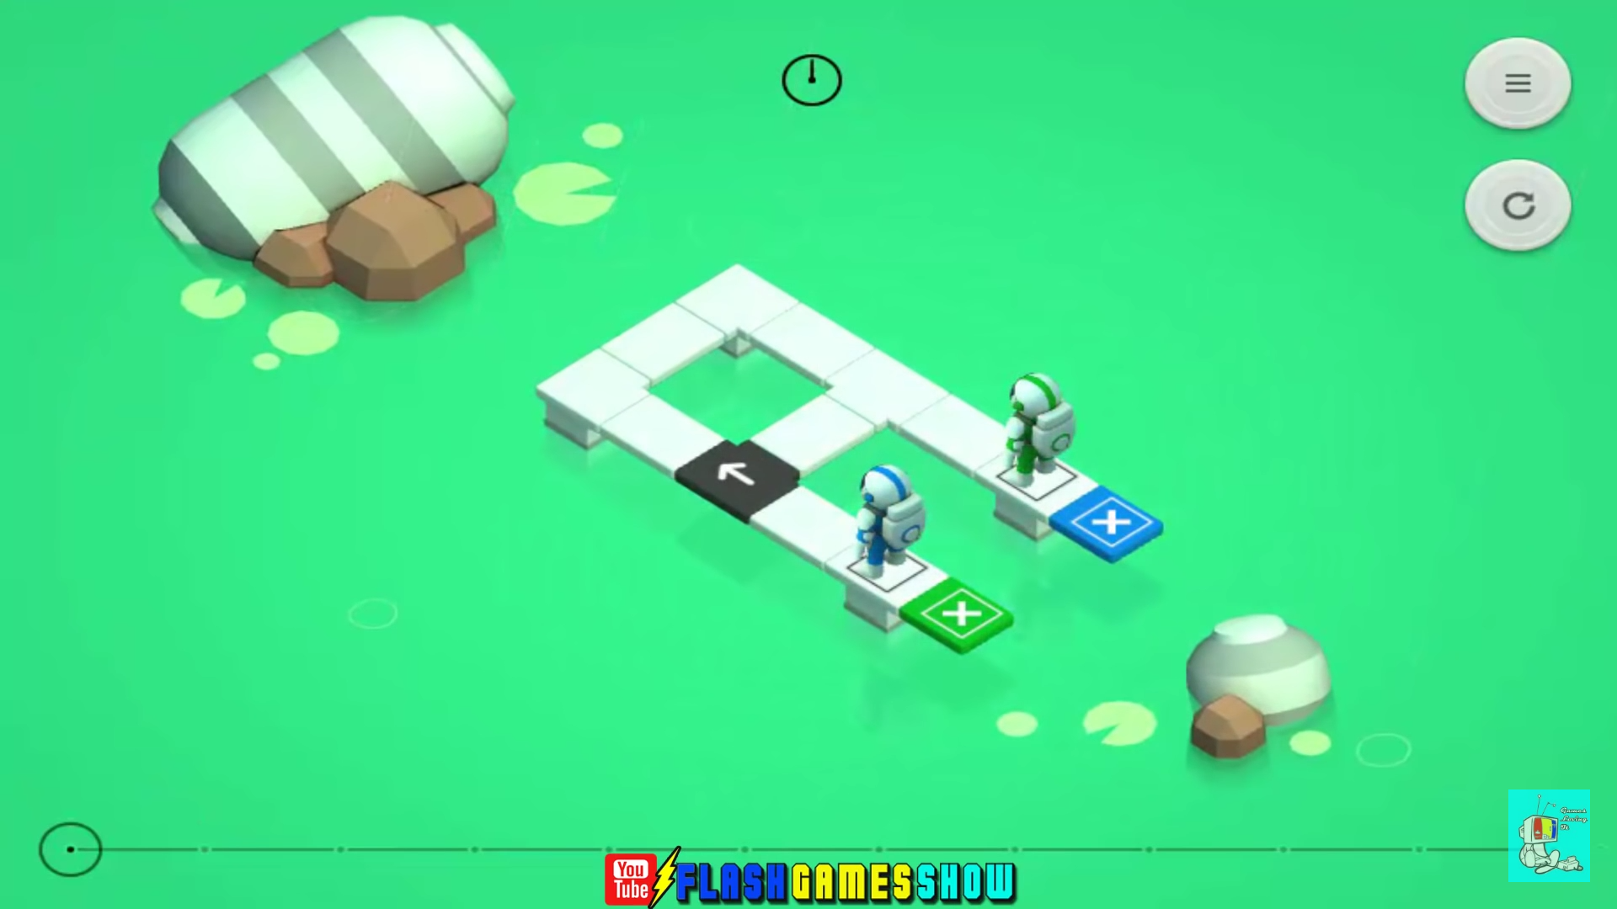

Astronauts will keep on moving, they will change direction only if they hit obstacle.

They will move together at once

Player can control the time by moving back and forward in the timeline below.

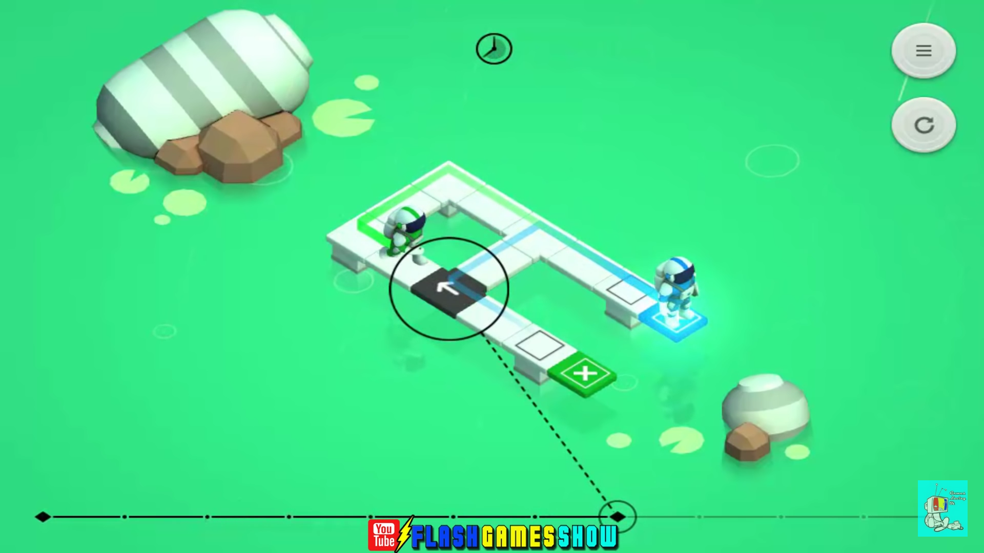

Therefore, player can pause the time to change the black arrow panel to guide them.

Since player controls the time, player also can revert back time so basically will not lose.

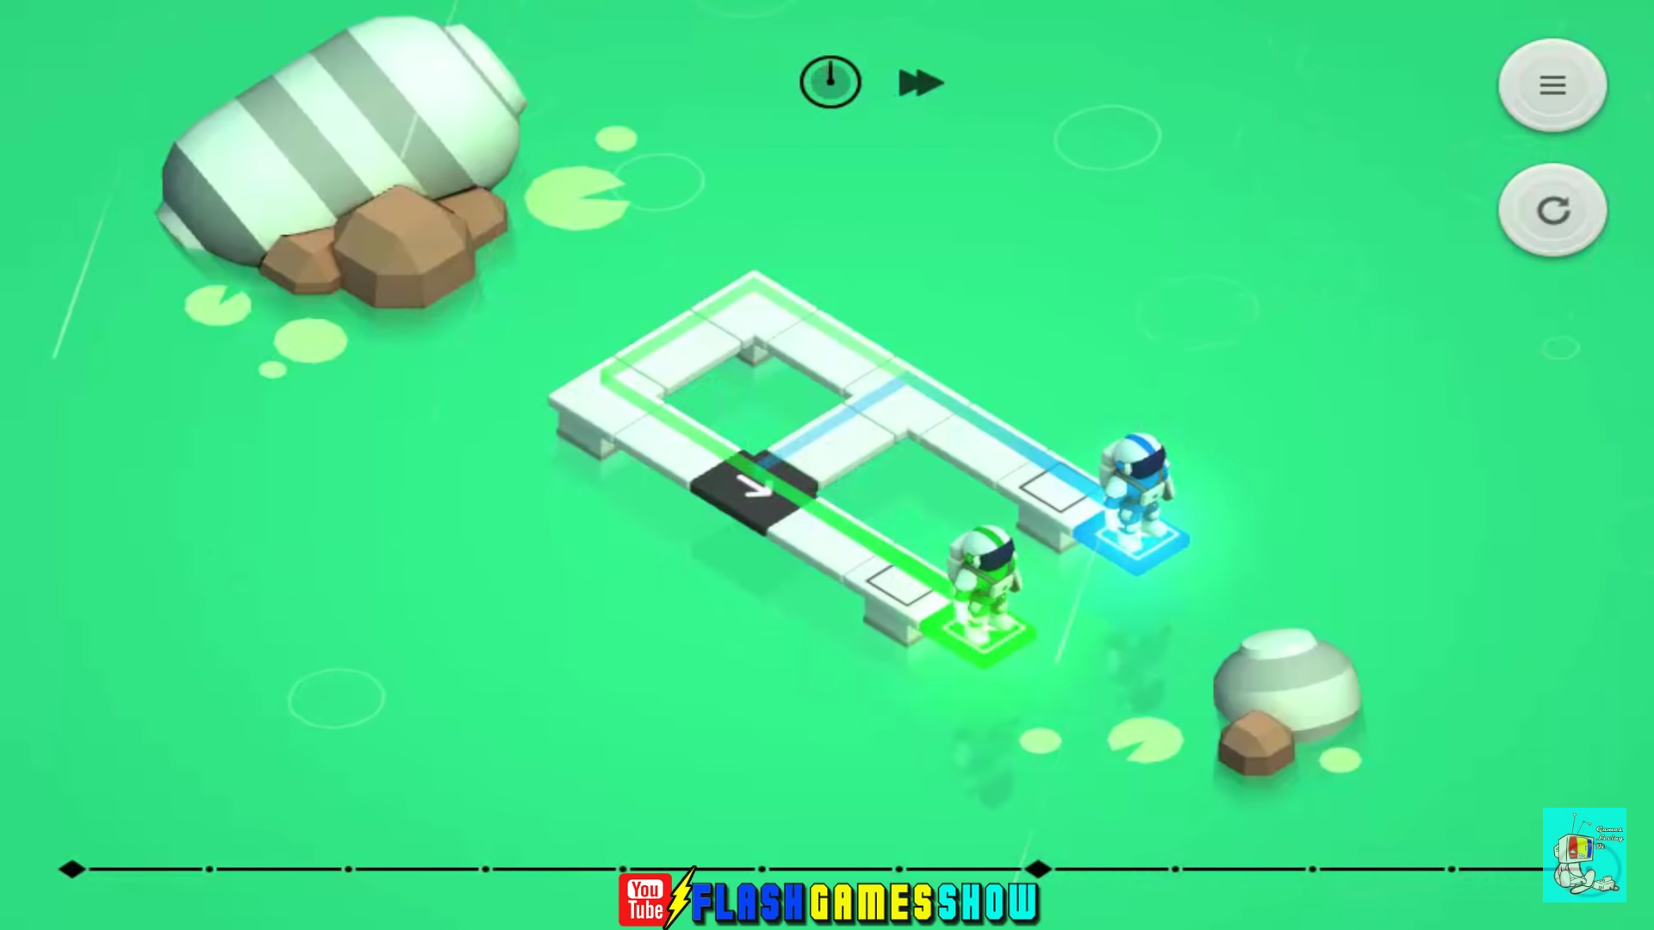

**Game Mechanics**

* **Character**: Astronauts with their respective colour on it
* **Items**: Black direction panels and action timeline
* **Environment**: 2.5D environment with puzzle path design including alien tentacle, obstacle switches, time travel portal and evil astronauts

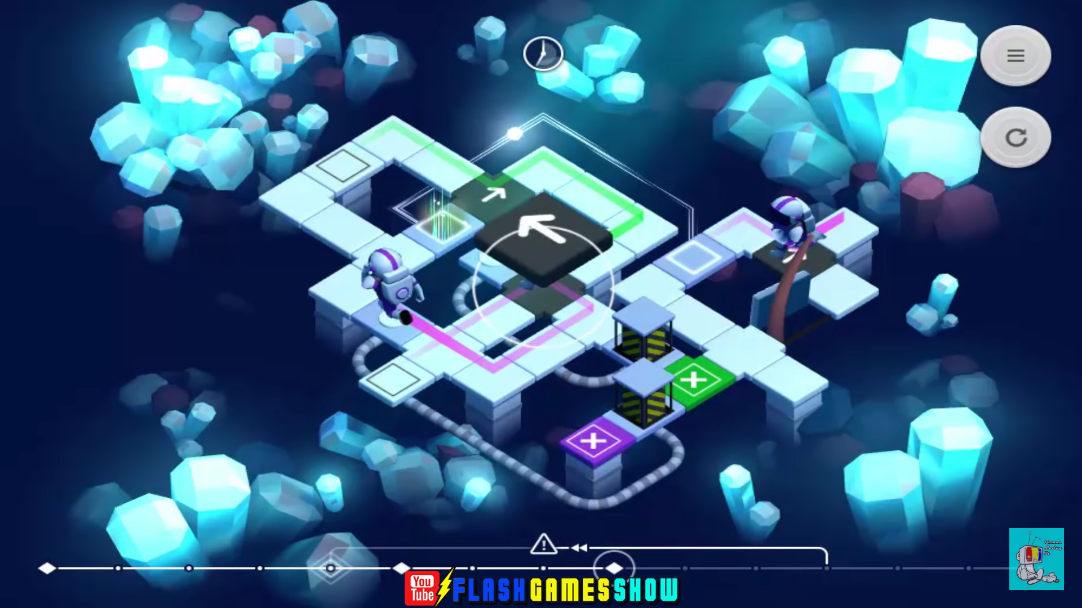

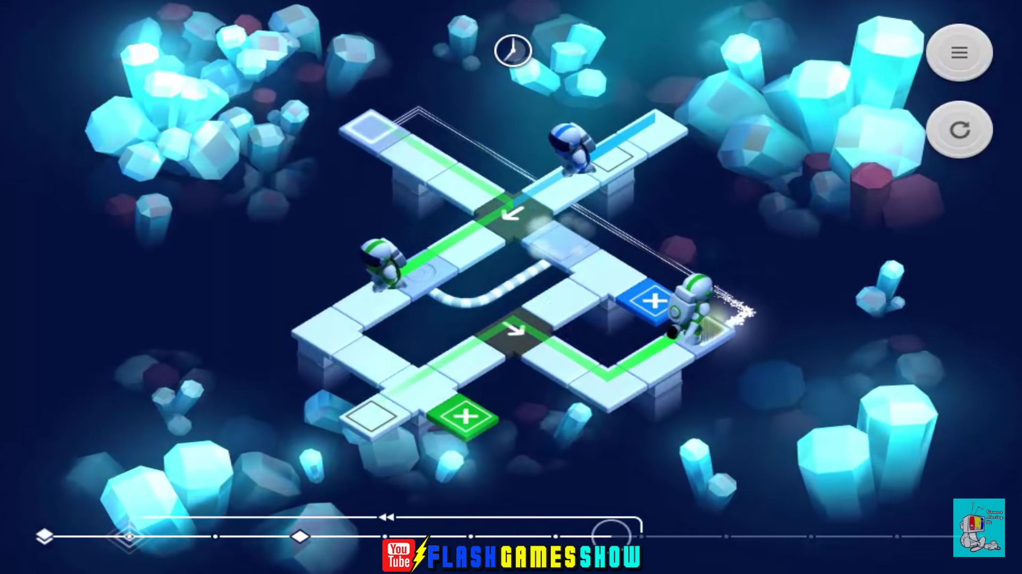

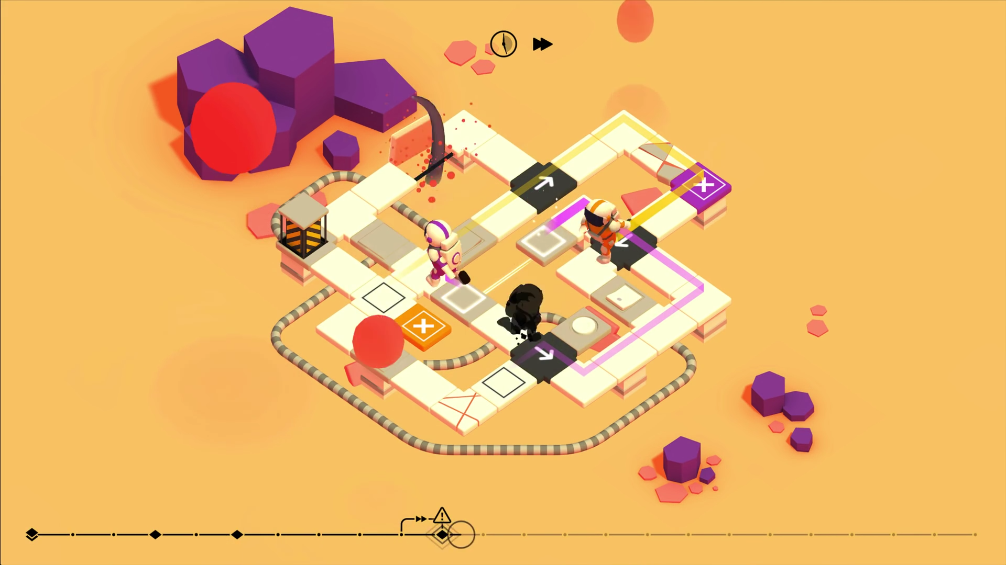

1. *Divine Gate (Old Version)*

* **Publisher**: GungHo
* **Genre**: Turn Based Puzzle Strategy RPG
* **Description**: Combat system by using drag and drop to gather similar colour of stone to a small area to perform attack thus damage the monsters (GungHo, 2016).

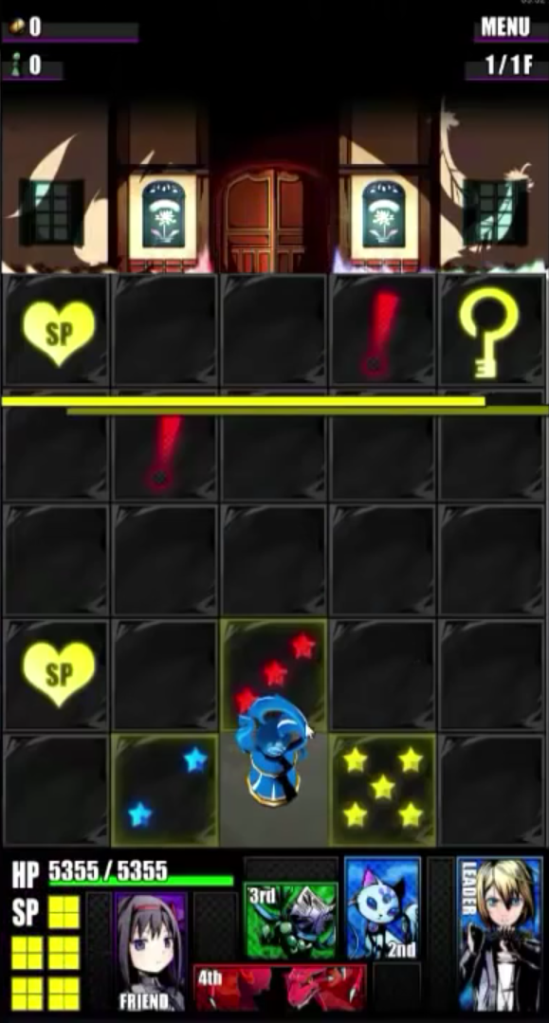**Win condition:**

Player needs to get the key and move to the door within the 5x5 tiles area

Player can pick which tile they want to step on

Yellow: Safe

Blue: Chance to fight monsters or get trap

Red: High chance to fight monsters or get trap

* Higher Star equal to higher risk or reward

SP: Item drop

Exclamation mark: Random things

Pass through the tiles without letting HP become 0

Monster Appear:

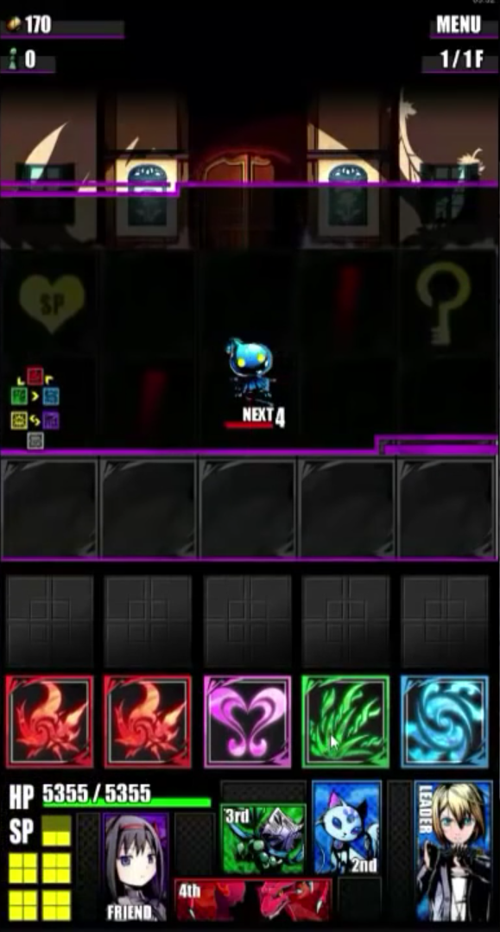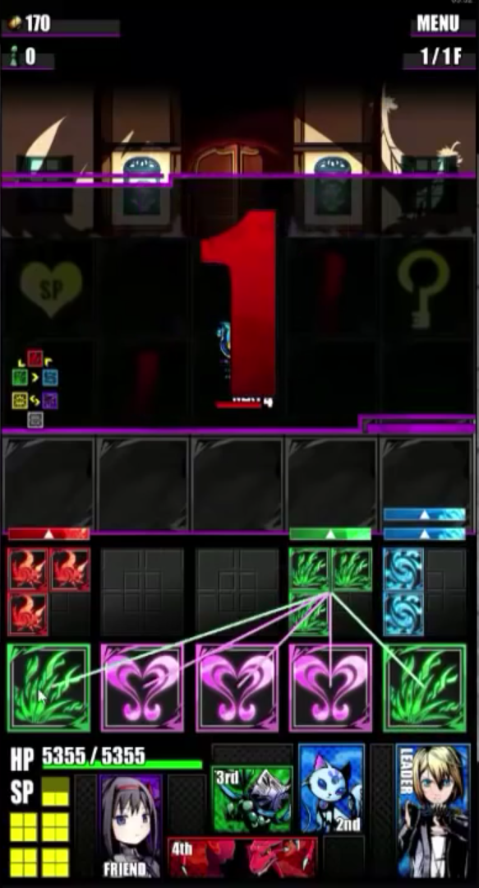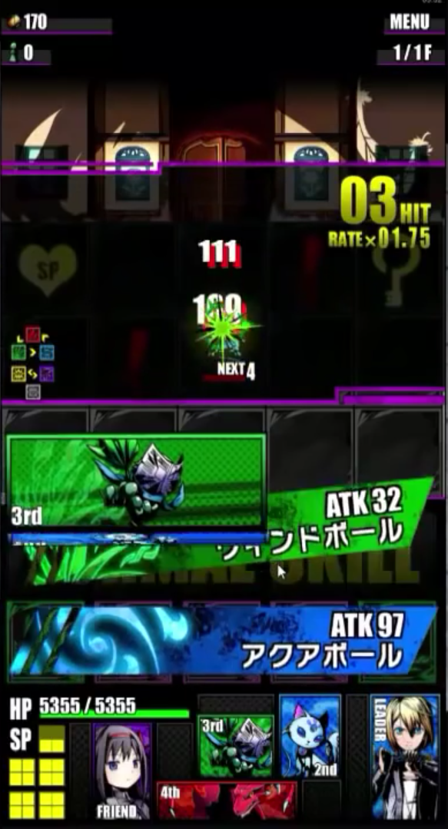

* Total of 5 colors and player has to put 2 or more stones into a box, maximum 5 stones per box
* Player given 5 seconds to complete the action
* Color stone transferred to the characters brought to deal damage to enemies

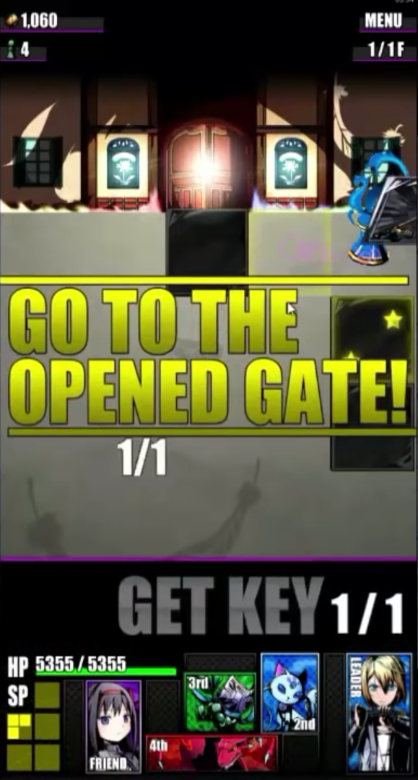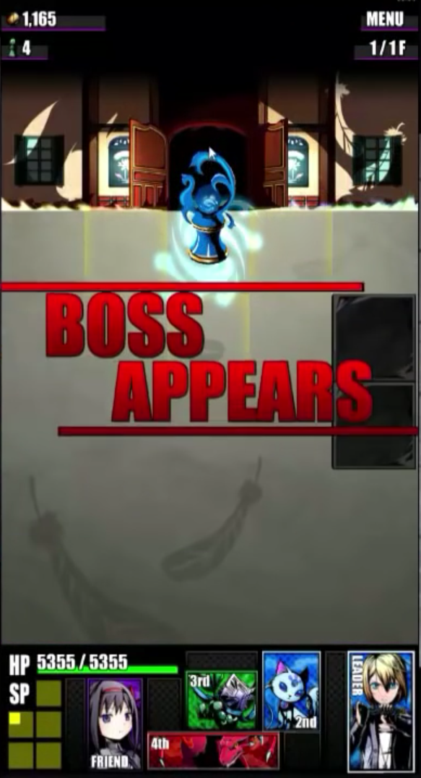

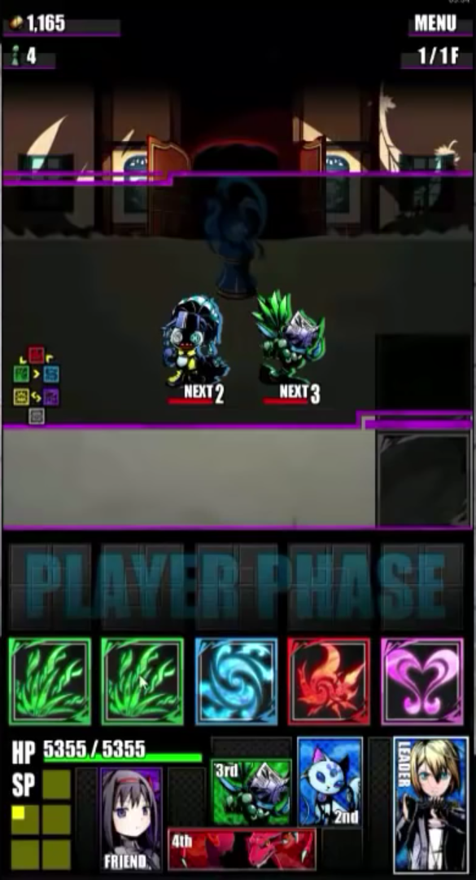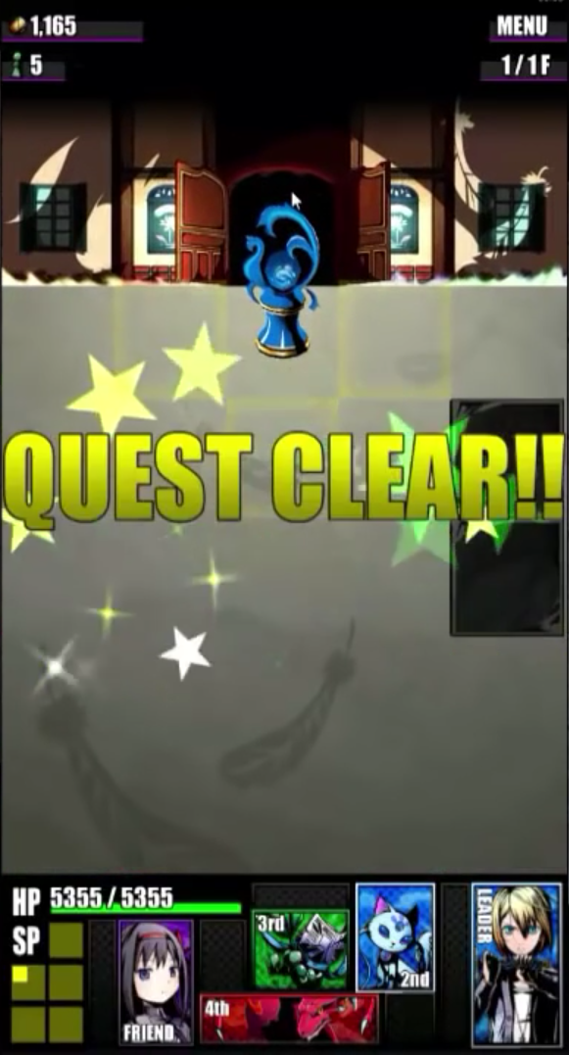

* Player has to get the key to unlock the door to exit
* Before exit player must deal with the boss first
* After getting the key player can choose to explore the tiles or direct go to the door

**Lose condition:**

Player’s HP become 0

**Game Mechanics**

**Character**: Player pieces and 5 characters that players brought to play

**Items**: Tiles to be selected and colour stones

**Environment**: 5x5 tiles, key location and indicator on each tile

1. *Where Shadows Slumber (Demo)*

* **Publisher**: Game Revenant
* **Genre**: Adventure Puzzle
* **Description**: Aid the main character in his search for redemption, in a rule of nature of anything that is not touched by light has freedom to change (Revenant, 2018).

**Win condition**:

Guide the main character to the cave exit

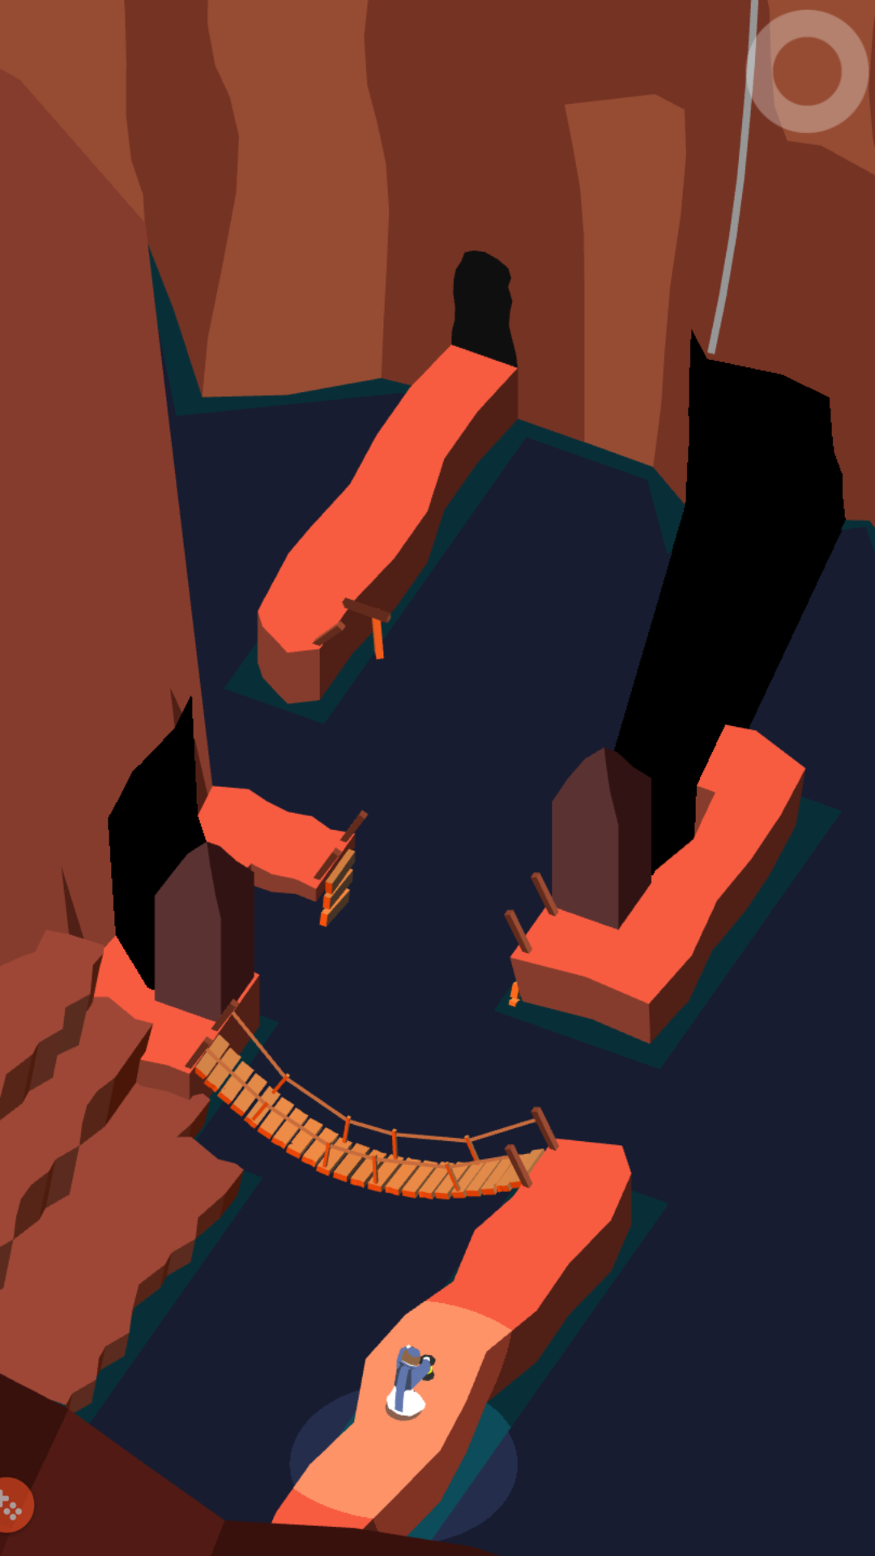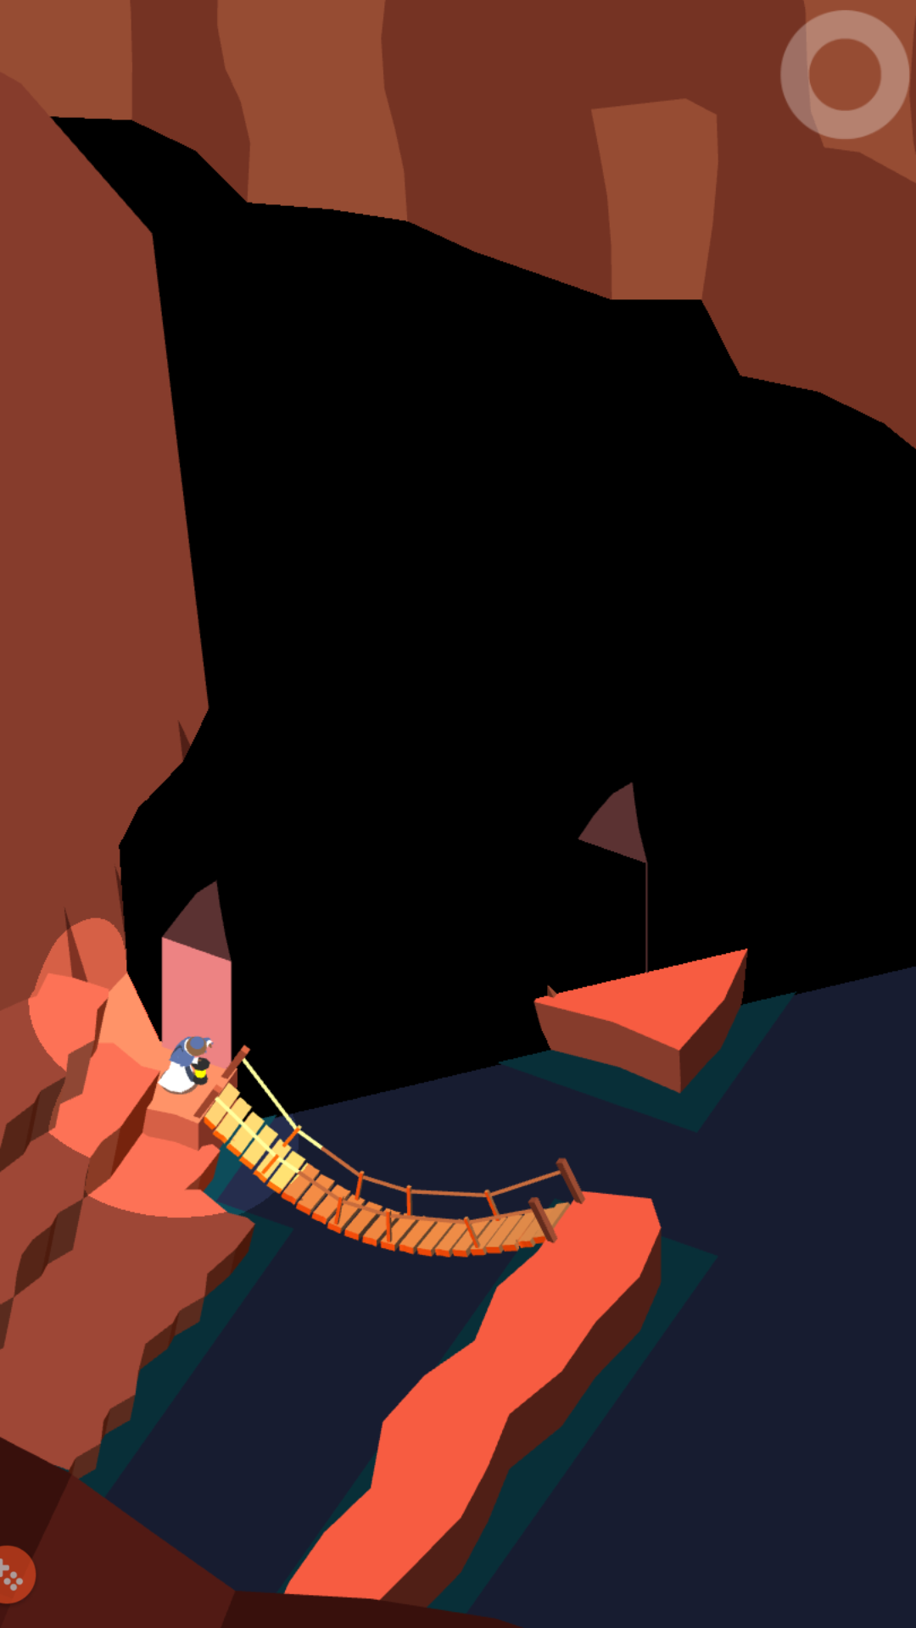

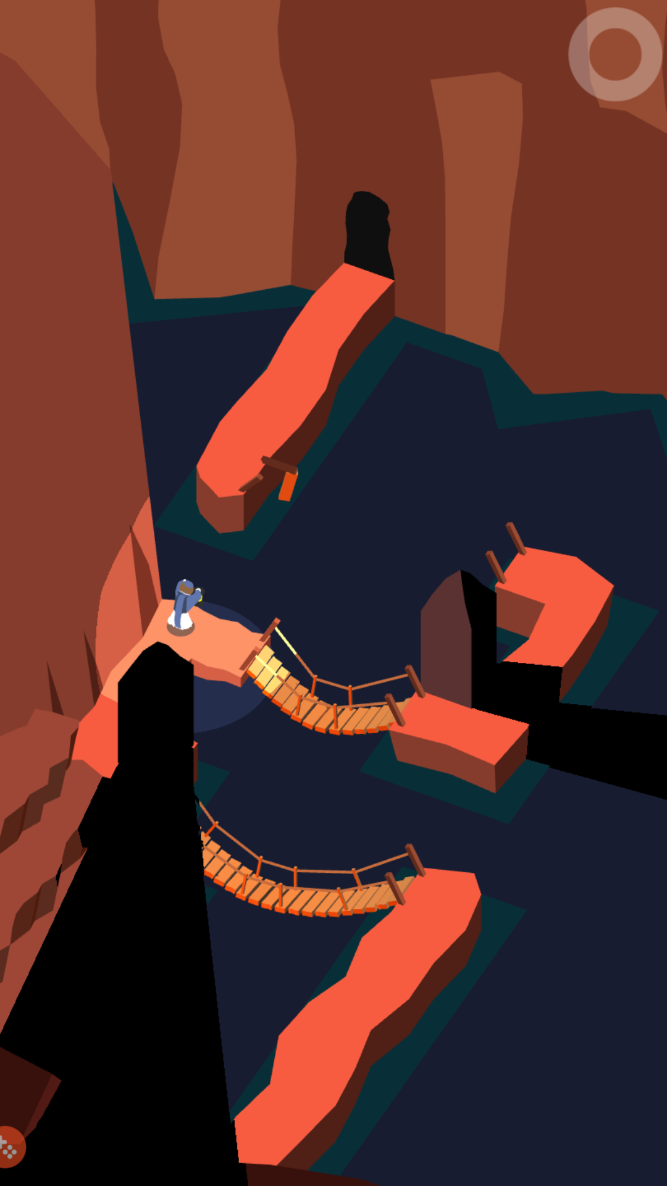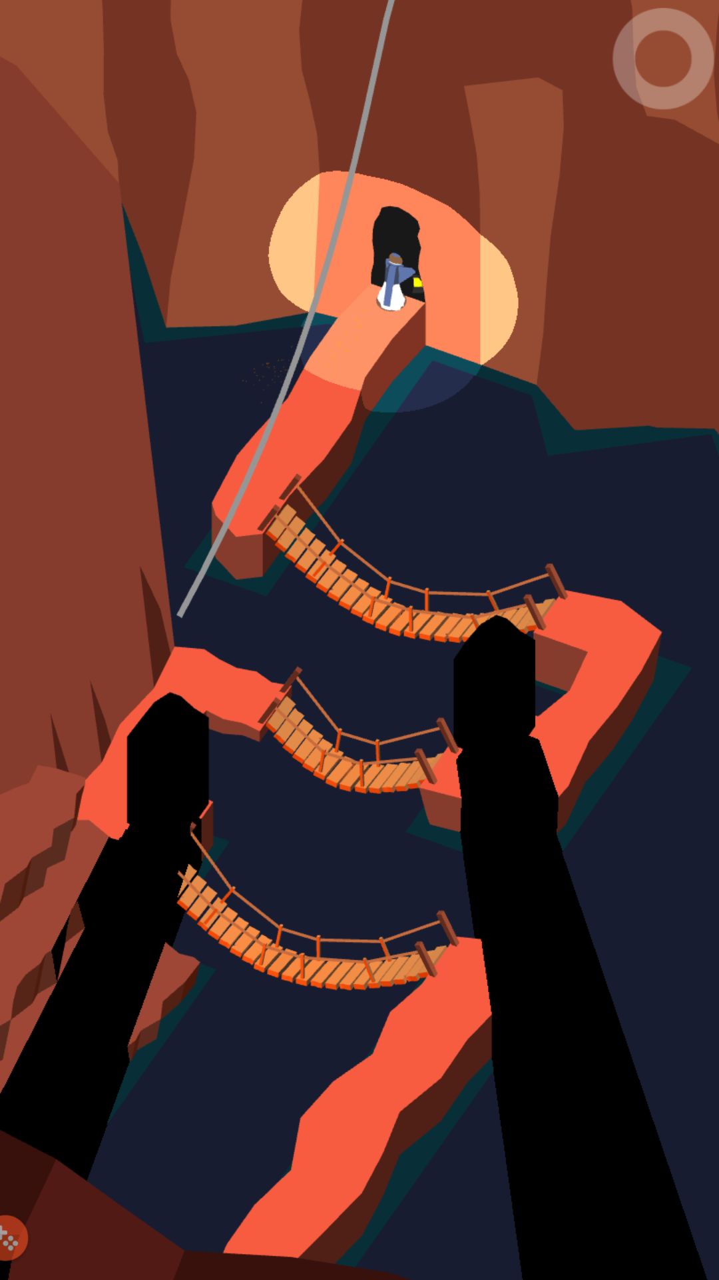

**Lose condition:**

None, since nothing will attack the player

**Game Mechanics**

**Character**: Main character

**Items**: Movable rocks

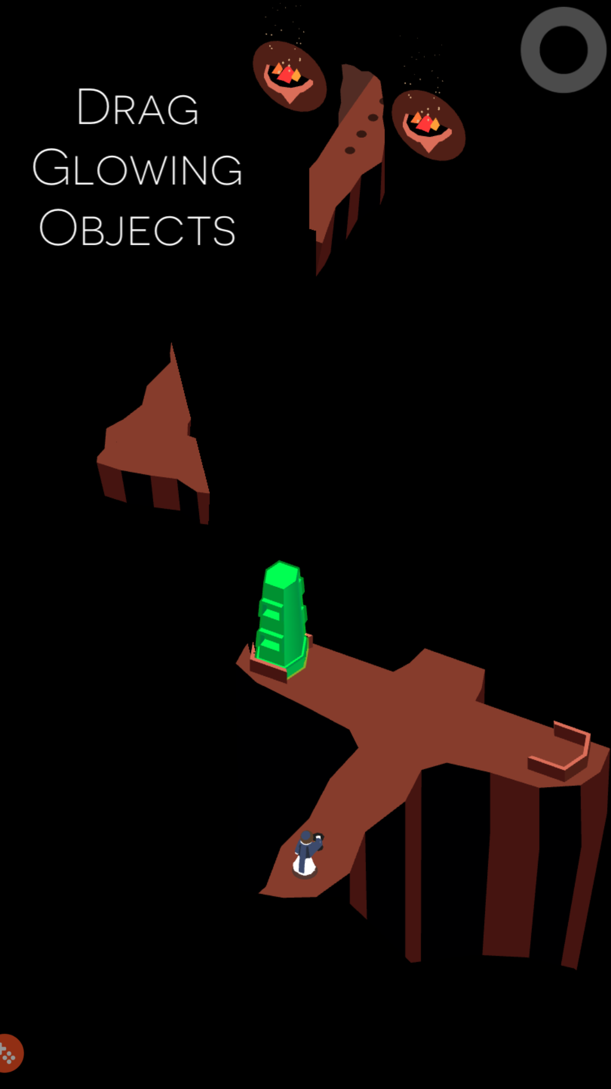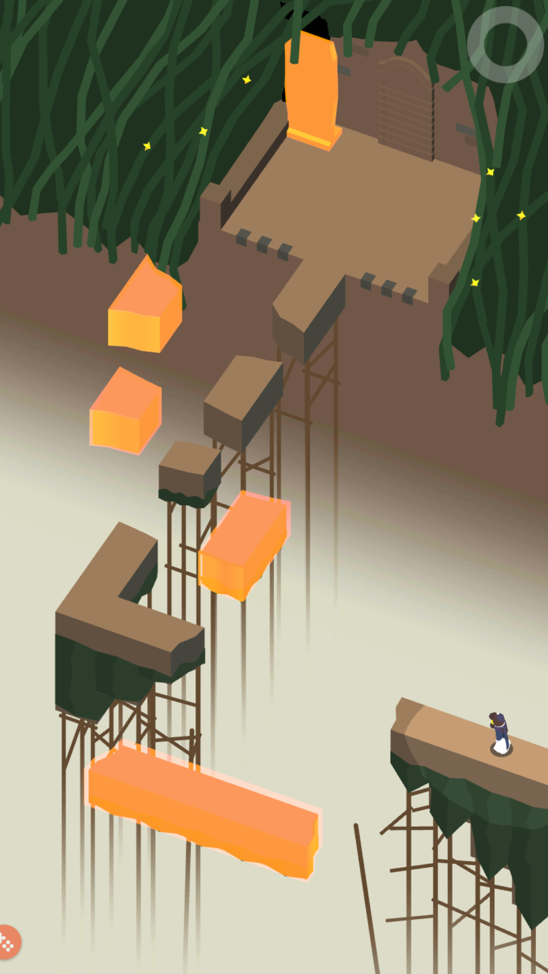

**Environment**: Map design, hidden path and buttons

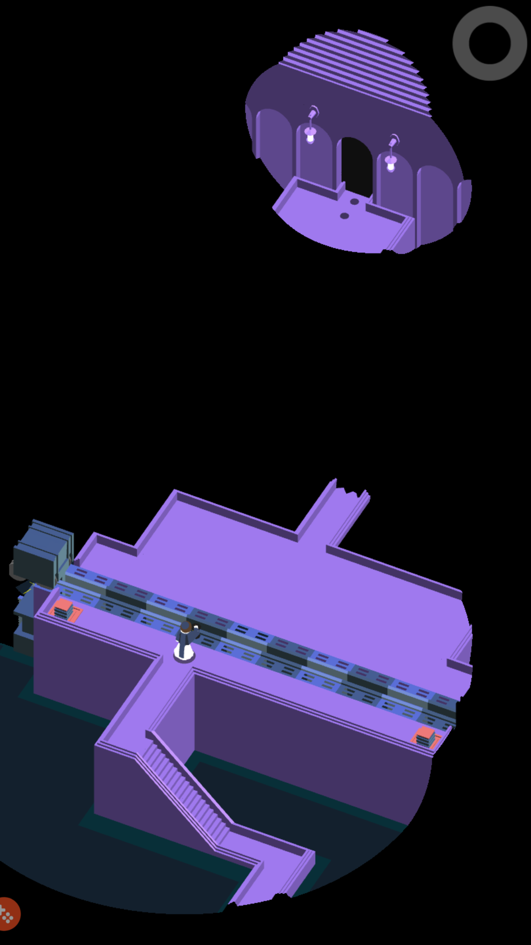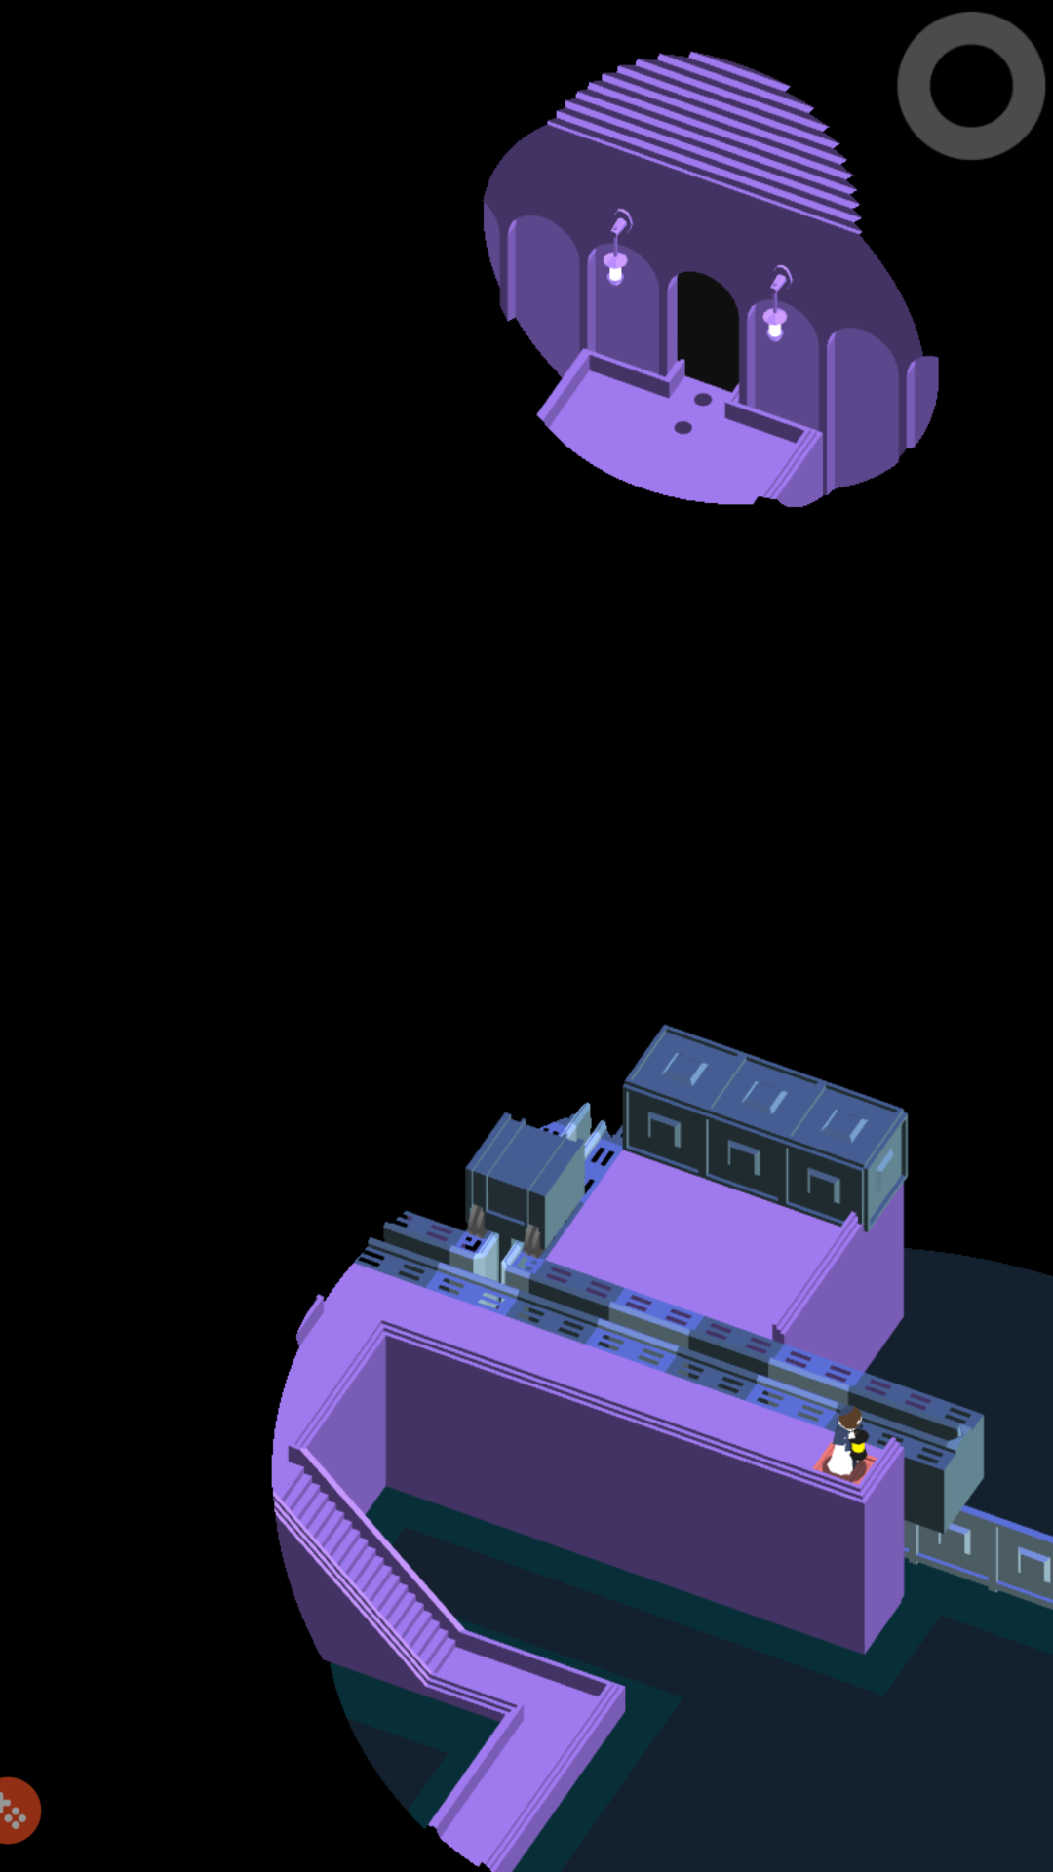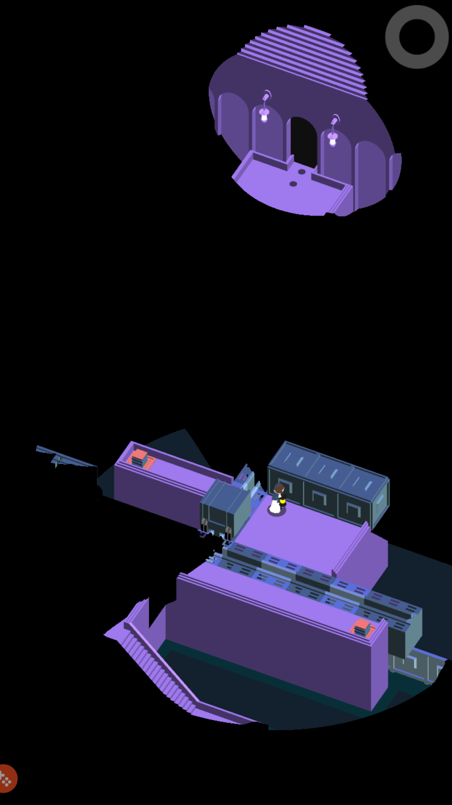

# Design & Method

The game planned to produce is a storytelling, semi-roguelike puzzle game with parts of horror elements. For now, its name is set as **“I’m the Skilled Driver”.**

## Game Overview

* Player as **a new cab driver** trying to work for **3 days** to earn money.
* Player can drive as many times as they like but there is an indicator (progress bar) which shows player’s progression per day and **4 customers are available** to choose from.
* After 3 days of working, your **total income** determines whether you clear the game.
* If any **fatal accidents** happened to player before last day, it is a GAME OVER
* If player **did not manage to earn enough money** after last day, it is also GAME OVER
* GAME CLEAR only happens when **survived all 3 days** and able to **earn enough money** at the end

## Level Design

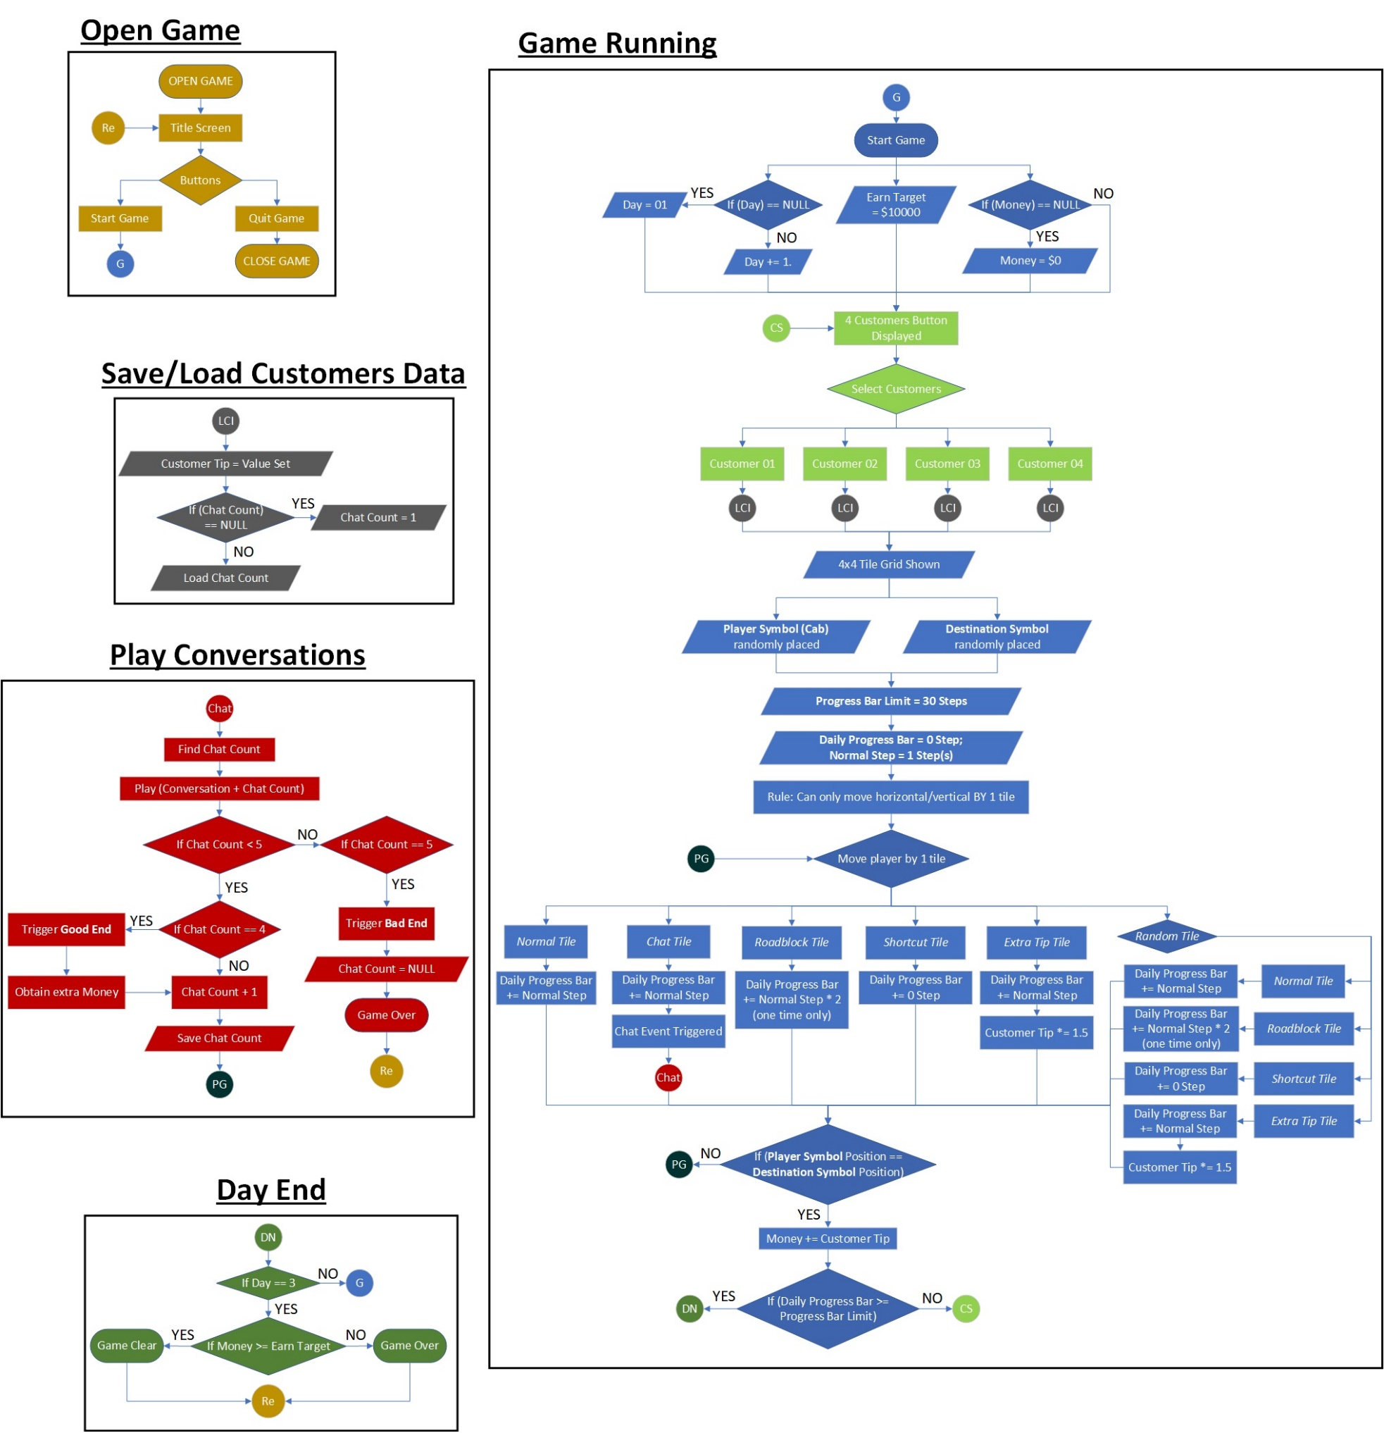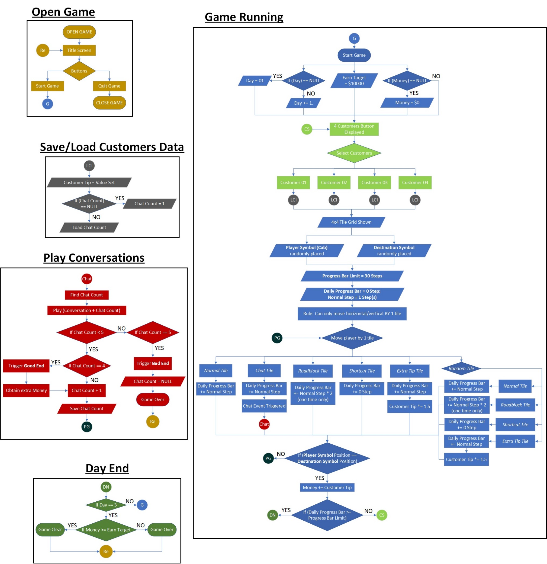

***FIGURE 3.2.1: Flow Chart of the Game I***

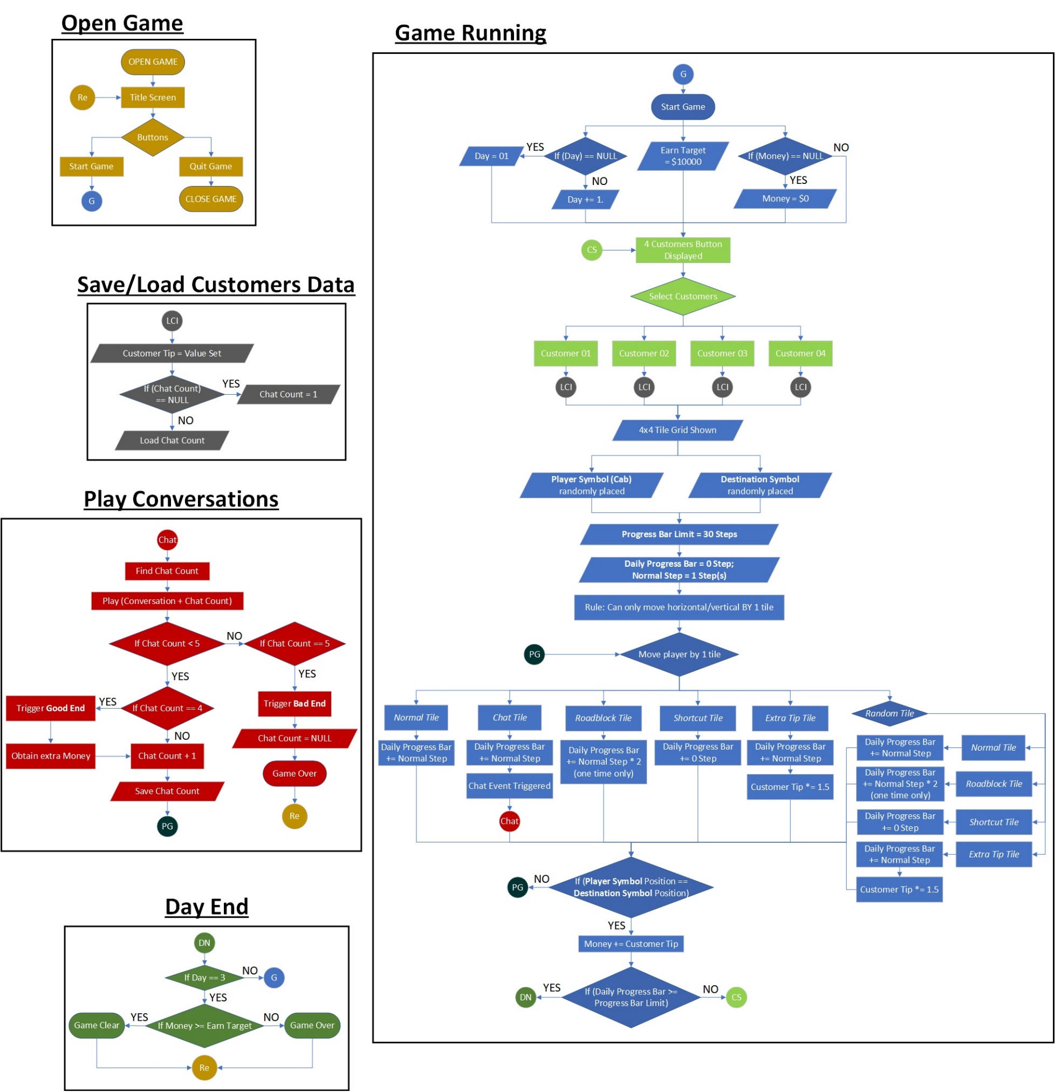

***FIGURE 3.2.2: Flow Chart of the Game II***

**Open Game**

Title screen would appear as well as all the buttons UI such as Start Game, Rules, Credits and Quit.

**Game Running**

Player will be initialized with day 1 and 0 amount of money, player will know that the amount required for 3 days are $10000.

A total of 4 customers will be displayed to let player to choose, a 4*4 tile grid would appear after that as well as the player’s car icon. Player only can move horizontal and vertical by 1 tile by swiping it. Progress bar will be shown where it will only increase when player move a step. After 30 steps it goes on to the next day.

Inside the 4*4 tile grid, 6 types of road tiles will appear randomly.

1. **Normal tile**: increase in progress bar by 1 only
2. **Chat tile**: increase in progress bar by 1 thus trigger chat event
3. **Roadblock tile**: increase in progress bar by 2
4. **Shortcut tile**: maintain the progress bar
5. **Extra tip tile**: increase in progress bar by 1 thus increase money get based on customers
6. **Random tile**: randomly choose a tile from above tiles except the Chat tile
7. **Destination tile**: increase in progress bar by 1 thus reload to customers display scene

When the progress bar is full, the player still can continue the game which means that player will not receive any penalty.

**Play Conversations**

This will only occur when player trigger the Chat Event, the number of chat is calculated and recorded throughout the game. The chat count is increased by 1 each time player passed through the Chat tile. If the chat count increased to 4, player will receive extra money based on the customers. But if the chat count increased to 5, player will reach a Game Over by getting killed by customers.

**Save/ Load Customers Data**

Each time player triggers the Chat event, the chat count will be increase by 1 and it is recorded with *PlayerPrefs* saving method via the *Unity* editor.

**Day End**

When day 3 is configured, it will match with the amount earn. If the amount is more than or equal to the requirement, a winning game screen would appear, else a game over screen appear. Next it would appear back to main title screen.

## Game Story

**Summary**

You as a player wanted to earn some money so you tried cab driving as your part-time job for 3 days. You will meet at least 4 people to be fetched as customers during the days but some of them might stop you from earning.

**Lore**

The game, in actuality, features a murderer who stole a person’s taxi and killed the person in the process. The murderer, now the player proceeds to use the taxi to earn some extra money. The taxi, however, was cursed due to the accidents so all customers would gradually become crazier and would kill the player as the victim’s revenge.

The murderer, after being killed multiple times by the customers, still go on with using the taxi after every reset. The victim then proceeds to solve the issue herself, personally threatening the player not to ‘touch my car’ ever again by a jump-scare.

## Adapted Concepts

**Mobile Input**

We’ve adapted the concepts of using ‘Swiping’ like *Monster Strike* as mobile input method, as seen from ***FIGURE 3.3.1***. In our script, the minimum swipe distance we set is 10% of the mobile screen height. To implement mobile input, two variables in the format of *Vector3* are needed to be used, while the first one is detecting the position for player’s first touch, and the second variable would be detecting the position where the player moved away their finger. The distance of the first touch to the end of the touch would be the touch distance. The system can detect whether the input is a horizontal swipe or vertical swipe by calculating the x axis and the y axis of touch variables mentioned above, after either vertical or horizontal movement is checked, the value of the first touch would be decrease by the value of last touch, if the value of first touch is greater, the movement would be going up in case of vertical movement.

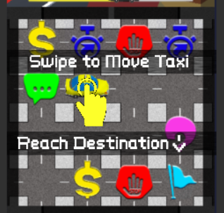

***FIGURE 3.3.1: Swipe Tutorial***

**Roguelike Puzzle**

Roguelike Puzzle is the main reference that we have for board generation, usually the turn-based movement like the one in *Dungeon Cards* was utilized in this kind of game. The player moves in turn-by-turn basis, and may trigger different scenarios when approaching special tiles in ***FIGURE 3.3.2***, which means the collision is going to be checked every time the player moves. After the player has cleared the level, a new map should be replaced with different placement of objects.

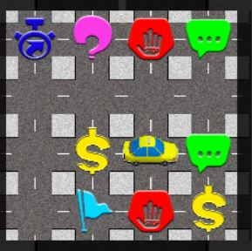

***FIGURE 3.3.2: Roguelike Puzzle***

**Progress Bar**

The use of Progress Bar in *Dungeon & Girls: Card RPG* in clearing dungeons are applicable in setting a time limit for the game’s **day calculation**. In *Dungeon & Girls: Card RPG*, the progress bar clearly shows the distance and the steps where in-game benefits and drawbacks are available.

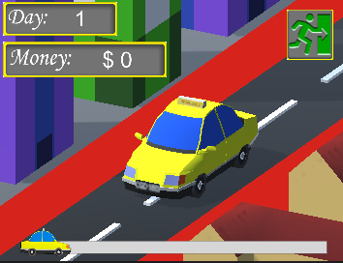

***FIGURE 3.3.3: Progress Bar in Game Prototype***

While in this mobile game, the progress bar as shown in ***FIGURE 3.3.3*** is used to indicate **the time spent** of driving the taxi in a day. The time spent in progress bar, however, is not clearly indicated to provide a challenge to the player for not having all information laid out and further decrease the game’s difficulty.

**Horror in Unexpected Segment(s)**

In *Baldi’s Basics in Education and Learning*, the sudden showing of horror in the cover of an old-fashioned education game is an example of horror in unexpected segments.

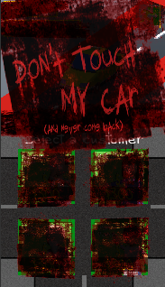

***FIGURE 3.3.4: Horror segment after talked too much with All Customers***

Like ***FIGURE 3.3.4***, this game intends to create the nearly similar effect, where a normal, simple puzzle game that only aims for earning money would be turned into a horror game that gradually limits the player’s control on the game when the players talks too much with a specific customer.

# System Implementation & Analysis

## Created Classes

1. **Game Manager & Board Manager**

There’s only one function for the game manager which is calling in the beginning of the stage, it would initialize and become the **holder of board manager**. *[refer to Appendix A]*

The board manager is utilized for the **creation of the puzzle** in the game. In order to function this class, the number of rows and columns of the puzzle that we want to create have to be determined, in our case, our puzzle map is a ‘4 x 4’ which has **4 rows and 4 columns** respectively.

The board manager is also the container of the tiles that we’re going to use, for instance the road tile, roadblock tile, shortcut tile, etc. *[refer to Appendix B]*

The board manager would **generate 16 road tiles** and **a border** which surrounding those road tiles, while the prefab of the player would be created at the position of the first generated road tile, which is the origin point. After the basic layout of the map was generated, the script would **produce the special tiles** such as roadblock tiles, shortcut tiles, the positions for them are randomly selected from one of the road tiles. To organize the generated tiles in *Unity* inspector view, a parent object named *‘BoardHolder’* would be spawned and it would collect all the generated tiles.

The two of the most important special tiles would be the *‘Chat Trigger’* and the ‘*Destination’*. The ***‘Chat Trigger’* would trigger the specific dialog** with the specific customer selected, the number of the player triggered the ‘Chat Trigger’ would also affect the content of the dialog. On the other hand, colliding with the *‘****Destination****’* tile simply means that the player has successfully reached the destination, the board would be **randomized and generated again**.

1. **Player & Flash Trigger**

‘Player’ class serves the role of **player controller** and **determines the event that triggered** by different type of special tiles. From the player controller perspective, player of using computer to launch may control the character by giving the input of ‘W, A, S, D’ which would move the character to four directions respectively, while for mobile control, we’ve activated the ‘Swipe’ for player to control the character. *[refer to Appendix C]*

Particularly for horizontal movement, we’ve added the function to **flip the sprite to the direction** based on the movement of the character, we’re not applying the sprite change for vertical movement is because the sprite looks weird when turning upside down.

By the way, we have added 2 integer variables which are ‘*blockX’* and ‘*blockY’* in Player script to **restrict the movement of player**, since our map has only ‘4x4', we need to stop player from moving out of the boundary. ‘*blockX’* is used for calculating how many times that the player has moved horizontally, for instance if the player is located at the top bottom corner of the map and it moves to the right once, the ‘*blockX’* would increase from 0 to 1, and the ‘*blockX’* would become 3 when the player reached the bottom right of the map. Oppositely, moving towards the left would decrease the ‘*blockX’* by 1. ‘*blockX’* should always follow two condition which are ‘*lower or equal to 3*’ and ‘larger or equal to 0’ to prevent player going beyond the boundary. Same logic has applied with ‘*blockY’* to maintain the vertical movement.

The *‘Flash Trigger’* script is to help player to **reveal the information of tiles** which nearby the character, we’ve added a cover to hide the details of the tile when the map creation, the player could only discover the tile details only when approaching them. This script is not having the ‘Flash’ function but the function of destroying the cover of the tile. *[refer to Appendix D]*

1. **Level Manager**

In *‘Level Manager’* class *[refer to Appendix E]*, the class contains the basic variables for the whole game’s puzzle mechanic: **Day**, **Money**, **ProgressBar**, and so on. These basic variables are added their relevant upper limits as well to determine **if the conditions are applicable for Game Clear or Game Over**. ***FIGURE 4.1.4.1*** shows the variable storage.

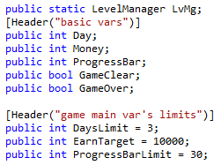

***FIGURE 4.1.4.1: Several Variables in Level Manager***

This class also deals with the **basic animations of 3D characters** applicable in the game, where the game would declare the type of animation played by the in-game 3D characters and calling when the characters are supposed to be destroyed after the animation has finished. In the function *dayStart()* shown in ***FIGURE 4.1.4.2***, the animation where the driver (player character) would enter the taxi is declared including the start of the **game’s background music**.

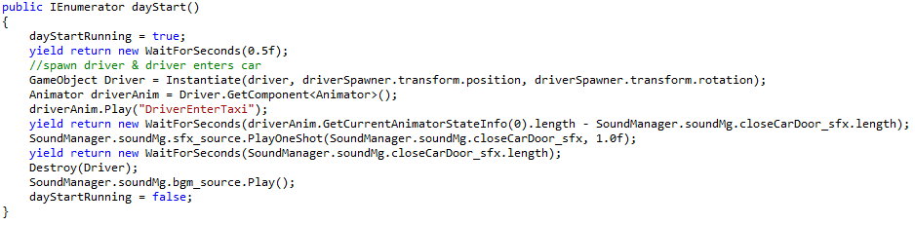

***FIGURE 4.1.4.2: dayStart() Function that controls Player***

1. **Dialogue Manager**

*‘Dialogue Manager’* script *[refer to Appendix F]* mains the application of *RPGTalk* plugin, where the talks would be pre-entered into a .txt file as shown in ***FIGURE 4.1.5.1***, and then being callback-ed by this script.

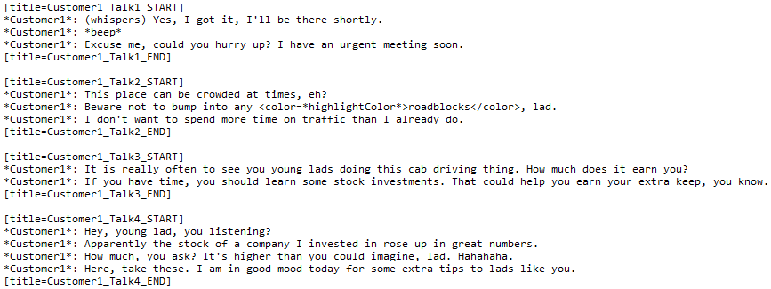

***FIGURE 4.1.5.1: Talk Contents of each Characters for Dialogue Manager Script***

This script handles the conversations the player has with other characters by calling a *newTalk()* function with respective functions to play after the talk. Based on the number of talks already initiated, the class would trigger different conversations as shown in ***FIGURE 4.1.5.2***.

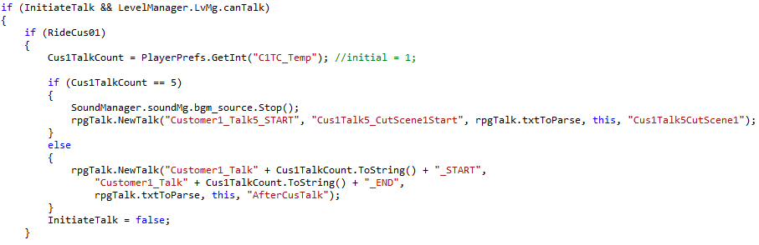

***FIGURE 4.1.5.2: newTalk() used in Update() of Dialogue Manager***

## Implemented Algorithms

1. **Algorithms for Board Creation**

The purpose of having the board manager class *[refer to Appendix A]* is to create the board in the scene. The map is created by the class in the beginning of the game, by applying the **for loop concept**. The number of the loops depends on the number we set for the ‘rows’ and ‘columns’ in board manager class.

For getting the position of each tile, a function named **‘Initialise List’** has been created, it would **store each of the position in a list**. For using the position that stored in the list, we implemented the **‘Random Position’**, it is basically a function which may **select one position from the Initialise List** for spawning special tile, and **remove the position that has been selected** from the list to avoid the issue of using a same position repeatedly.

A ‘**Spawn Object**’ function has been developed for spawning special tiles, it requires two input which are: which object to spawn and spawn the object for how many times. The function would firstly activate **‘Random Position’** to retrieve an available random position, and spawn the object to that position. By calling the function with different input, multiple objects could be created in scene with random position given.

1. **Algorithms for Dialogue Sequence**

While the dialogues are not intended to be saved manually by the player, the records of the conversation would be recorded in *PlayerPrefs* via integer-type variable. There are 5 *PlayerPrefs* variables that are used to contain these records. When referred to the Dialogue Manager script *[refer to Appendix F],* the *PlayerPrefs* are:

* CusTalkCount1
* CusTalkCount2
* CusTalkCount3
* CusTalkCount4
* BadEndCount

While CusTalkCount1, 2, 3, and 4 are used to store the respective conversation amount carried out to each customers, BadEndCount is the variable that is used to contain how many ‘Bad Ends’ featuring death of player has been carried out throughout the game.

1. **Algorithms for Horror Segments**

When the variable BadEndCount from Dialogue Manager *[refer to Appendix F]* exceeds 4 times, a ‘mysterious customer’ would be the only customer of selection, as shown in the *Update()* of Level Manager script [refer to Appendix E]. The game would then proceed to become ‘unplayable’, where the game does not allow player to accept any input in-game.

The stalemate, however, can be resolved when pressing a hidden ‘ReStart’ button shown above the game’s title which could only appear when the variable BadEndCount reaches the value of more than or equal to 5.

## User Manual/Guide

It is recommended that players start by reading the **RULES** section of the game first before entering the game. As mentioned in the rules, player need to tap to choose a customer which they wanted to fetch. In order to move the player’s car, they have to swipe it. Please take noted that progress bar raises for each move. The goal of the game is to earn the $10000 within 3 days and the lose condition would be either insufficient of amount at the last day or trigger any bad ends. Lastly, player is reminded to recognize all the icons so that player can have smoother progress.

## Test Cases

There are at least 3 people were invited as tester to the game after finished developing. Most of them are performing Functionality Testing to identify bugs and errors that may affect the user-experience. The key features of this testing is to determine whether the application is working accordingly to the specifications which is considered black-box testing. Tester took their time to look for game play issues, graphic issues, audio issues and many more. Even the process of installation is tested.

Besides, Play Testing is also used for the project. The aim is to analyses non-functional features such as fun factors, difficulty levels and balance. Any reviews or comments are welcomed. The key features is to judge the game rather than the facts and to check the game is working in a well-structured manner.

The results of the testing is considered satisfying as the bugs and errors that occur are quite minor. Bugs do appear especially for the chat system and puzzle elements. The requirement for the money amount is being adjusted to balance the game. Other than that, the game runs well as per expected.

# Conclusion

Throughout this assessment, a mobile application featuring a semi-roguelike puzzle game with parts of horror elements of a taxi driver is created. The game is made with the game environment incorporated with the 3D objects, mixed with 2D sprites that act as user interfaces that affect the animations of the 3D objects in the game.

In the process of developing the output, the main objectives of creating a mobile application game with a puzzle theme and contains level continuity have been created. The creation of the game prototype starts with the PC (Windows) format and was then converted into the Android build. While the puzzle theme has been included, the puzzle segment of the game is not the focus, but the hidden horror segment of the game. The level of continuity for this game is complete from the beginning till the end, which ensures the puzzle element would not be entirely similar per game.

While we are decently satisfied with the output, there were a few adjustments that could be made given the opportunity and time. First, the animation was made simple due to the restriction of the mobile processing performance for our testing device, and thus several animation sequences were to be cut short. The second improvement could be made via the mobile inputs. While swiping feature works on the game well, it would be recommended to work on a simpler input for the players in the future, like a touch-and-release input.

# Workload Matrix

|  |  |  |  |
| --- | --- | --- | --- |
| **WEIGHTAGE** | **ANG CHEE SIAH (TP038259)** | **LIM ZHI DA (TP041644)** | **SEE RONG JIE (TP038306)** |
| *Level Design* | 30% | 35% | 35% |
| *Game Story Design* | 50% | 25% | 25% |
| *Asset Creation* | 15% | 15% | 70% |
| *Programming*  *(Story & Dialogues)* | 50% | 30% | 20% |
| *Programming (Puzzle)* | 25% | 60% | 15% |
| *Documentation* | 30% | 35% | 35% |
| **TOTAL WEIGHTAGE** | **33.33 %** | **33.33%** | **33.33 %** |
| **SIGNATURE** |  |  |  |

# References

1. Enix, S., 2018. *Steam | Lara Croft GO.* [Online]   
   Available at: https://store.steampowered.com/app/540840/Lara_Croft_GO/  
   [Accessed 10 July 2018].
2. Games, S., 2018. *Nintendo Games: Snipperclips.* [Online]   
   Available at: https://www.nintendo.com/games/detail/snipperclips-switch  
   [Accessed 3 July 2018].
3. GungHo, 2016. *QooApp | Divine Gate.* [Online]   
   Available at: https://apps.qoo-app.com/en/app/1733?from=search:q%3DDivine%2520Gate%26source%3D-1  
   [Accessed 5 July 2018].
4. Loiu, 2018. *Google Play | Causality.* [Online]   
   Available at: https://play.google.com/store/apps/details?id=com.lojugames.android.Causality&hl=en  
   [Accessed 30 June 2018].
5. LUNOSOFT, 2016. *Google Play | Dungeon & Girls: Card RPG.* [Online]   
   Available at: https://play.google.com/store/apps/details?id=com.iqubi.dungeonandgirlsunity&hl=en  
   [Accessed 30 June 2018].
6. Magni, M., 2017. *Google Play | Mekorama.* [Online]   
   Available at: https://play.google.com/store/apps/details?id=com.martinmagni.mekorama&hl=en_US   
   [Accessed 27 June 2018].
7. MarkerLtd., 2018. *Steam | Samsara.* [Online]   
   Available at: https://store.steampowered.com/app/652880/Samsara/  
   [Accessed 26 June 2018].
8. Mixi, 2015. *QooApp | Monster Strike.* [Online]   
   Available at: https://apps.qoo-app.com/en/app/1498/%E3%83%A2%E3%83%B3%E3%82%B9%E3%82%BF%E3%83%BC%E3%82%B9%E3%83%88%E3%83%A9%E3%82%A4%E3%82%AF  
   [Accessed 23 June 2018].
9. mystman12, 2018. *itch.io | Baldi's Basics in Education and Learning.* [Online]   
   Available at: https://mystman12.itch.io/baldis-basics  
   [Accessed 30 June 2018].
10. Pixels, 7., 2018. *Google Play | Dungeon Cards.* [Online]   
    Available at: https://play.google.com/store/apps/details?id=com.The717pixels.DungeonCards&hl=en  
    [Accessed 22 June 2018].
11. Playdead, 2018. *Inside | Playdead.* [Online]   
    Available at: http://www.playdead.com/games/inside/  
    [Accessed 24 June 2018].
12. Revenant, G., 2018. *Google Play | Where Shadows Slumber.* [Online]   
    Available at: https://play.google.com/store/apps/details?id=com.jfmc.extinguish  
    [Accessed 11 July 2018].
13. shiba, m., 2017. *1BeatHeart.* [Online]   
    Available at: http://1beatheart.nobody.jp/  
    [Accessed 17 June 2018].
14. Sinsiroad, 2016. *Google Play | Potion Maker.* [Online]   
    Available at: https://play.google.com/store/apps/details?id=com.sinsiroad.potionmaker&hl=en  
    [Accessed 25 June 2018].
15. Thekla, 2018. *Steam | The Witness.* [Online]   
    Available at: https://store.steampowered.com/app/210970/The_Witness/  
    [Accessed 15 July 2018].
16. vgperson, 2017. *1BeatHeart | vgperson translation.* [Online]   
    Available at: http://vgperson.com/games/1beatheart.htm  
    [Accessed 17 June 2018].

# Appendix A: Game Manager Script

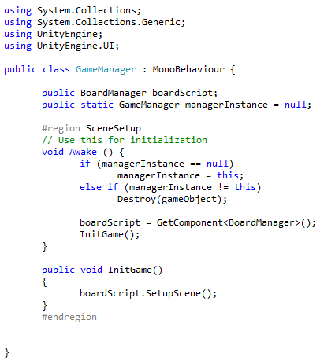

# Appendix B: Board Manager Script

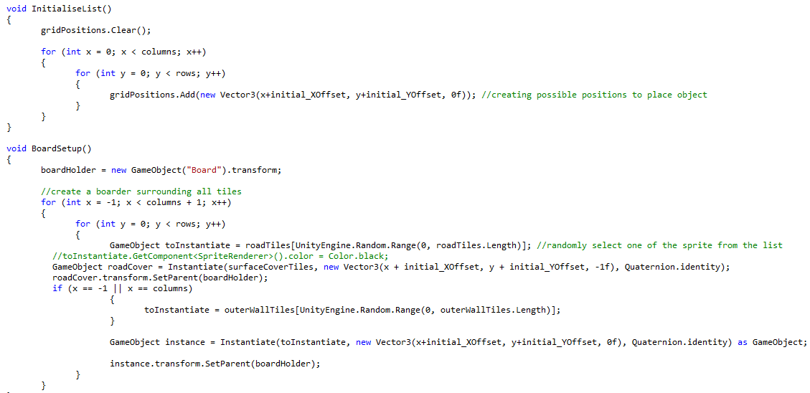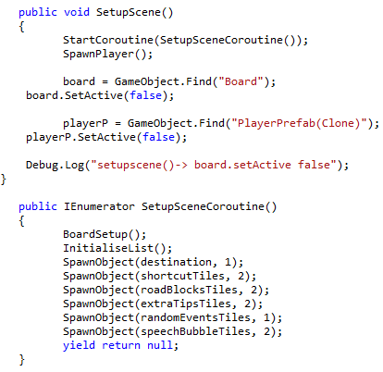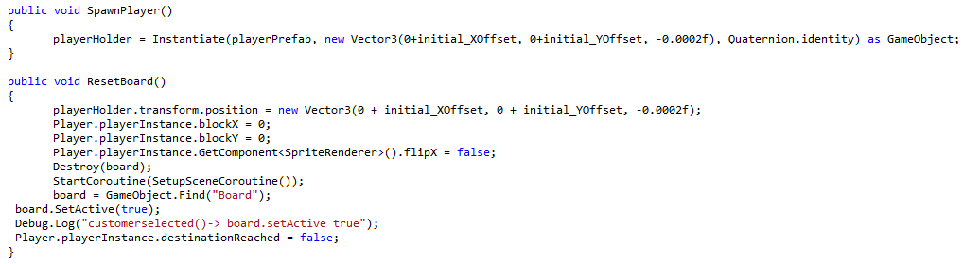

# Appendix C: Player Script

**PC Controls:**

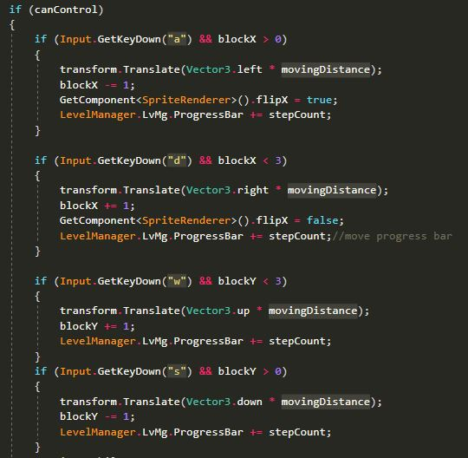

**Mobile Controls**:

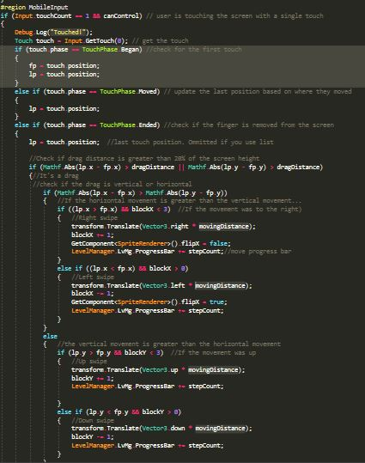

# Appendix D: Flash Trigger Script

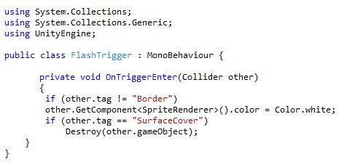

# Appendix E: Level Manager Script

**Variables:**

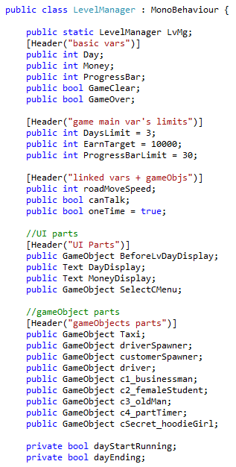

**Awake(), Update() and Miscellaneous Functions:**

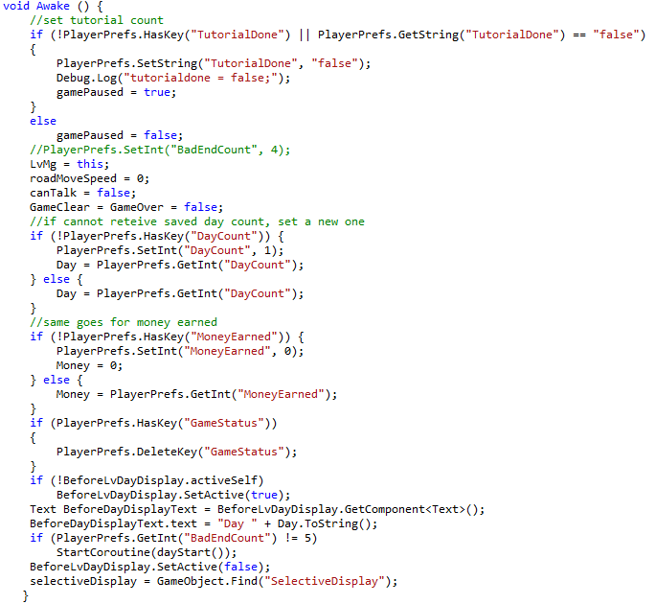

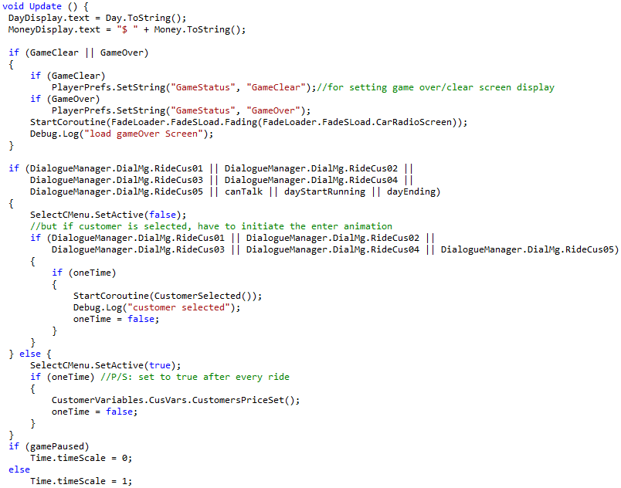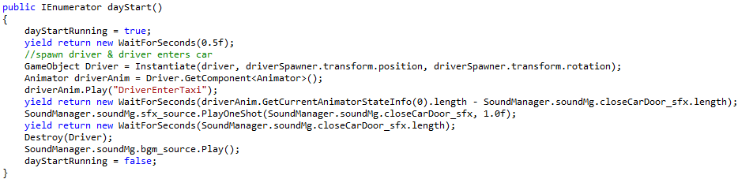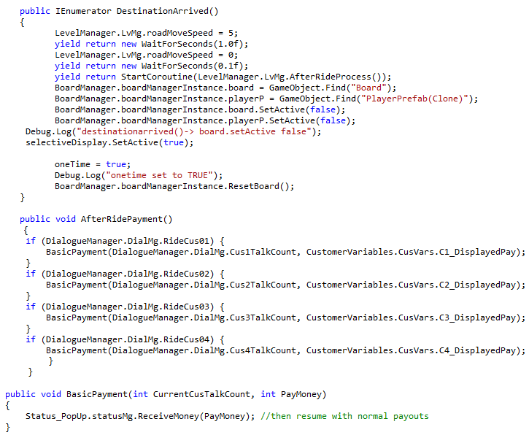

# Appendix F: Dialogue Manager Script

**Variables:**

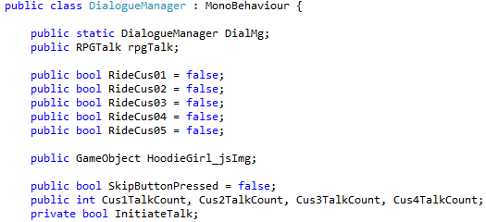

**Awake(), Update() and Miscellaneous Functions:**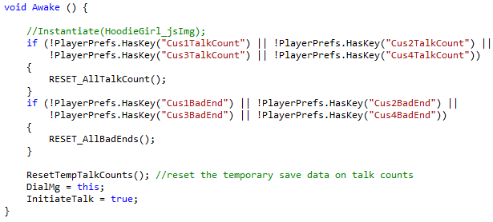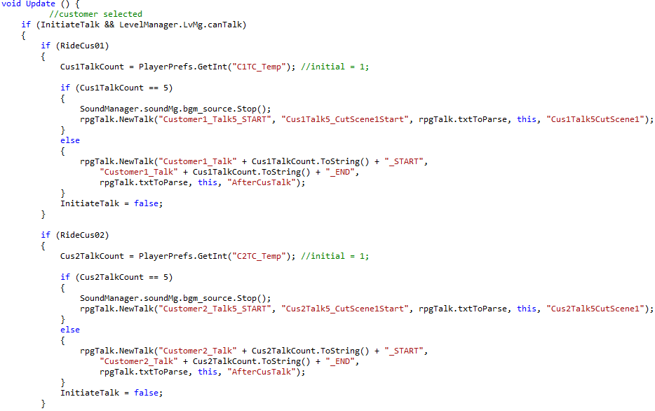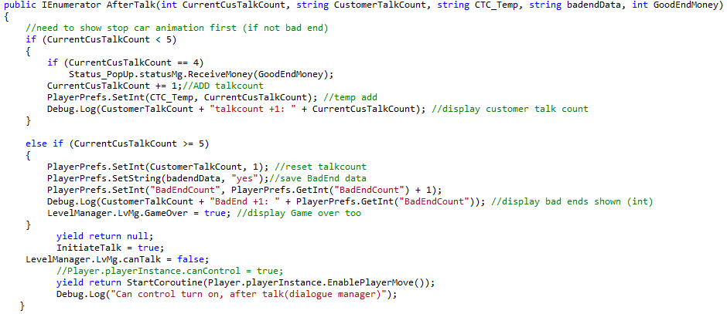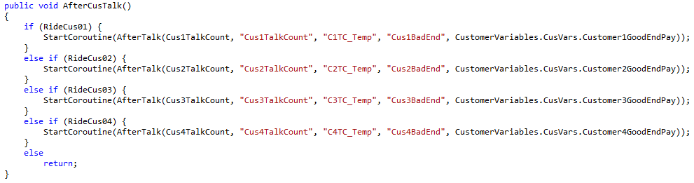

# Appendix G: *itch.io* Website of **I’m The Skilled Driver**

